NATIONAL UNIVERSITY OF MODERN LANGUAGES
Program fundamental Lab report # 1

SUBMITTED BY:
ZULQARNAIN HASSAN

SUBMITTED TO:
SIR AAQIB ADEEL
Roll No : SP21379
Faculty: Engineering and computer science
Department: Software engineering
Section: BSSE-1-A-afternoon

Date 17-02-2022
Topics
- Header file
- Pre-processor directive
- Cout
- Main function
- endl
Header file:
C++ contains many header files. Header files contain information that is required by the program in which these are used.
For example
Iostream.h,conio.h ,cmath etc.
Syntax
#include<iostream>
Pre-processor directive:
- It is used to include header files at the beginning of the program.
- It is a code for the compiler to include a header file.
For example
#include etc.
The syntax of the preprocessor directive to include a header file in a program is.
#include<name of header file>
It begins with a #sign, followed by the word include, and then the name of the header file is written within angled brackets.
The main function:
- Every program must contain the main function.
- The execution of the program begins from the main function.
Syntax
Main()
{
Body of program
}

The cout statement:
The cout statement is used to output text or values on the screen. The keyword cout insertion operator on its right side is two less than signs (<<).
Syntax
Cout<<” hello world”;

Endl:
Endl is used to insert a new line character and flush the stream.

Write a program that To print ‘hello world and BSSE without using endl
#include<iostream>
using namespace std;
main()
{
cout<<" hello world";
cout<<"BSSE";
}
OUTPUT:-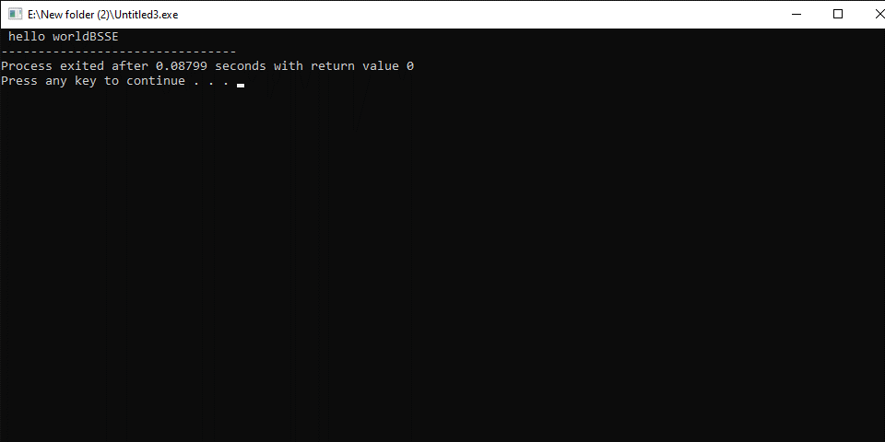

Write a program that To print ‘hello world and BSSE using endl
#include<iostream>
using namespace std;
main()
{
cout<<" hello world"<<endl;
cout<<"BSSE";
}

OUTPUT:-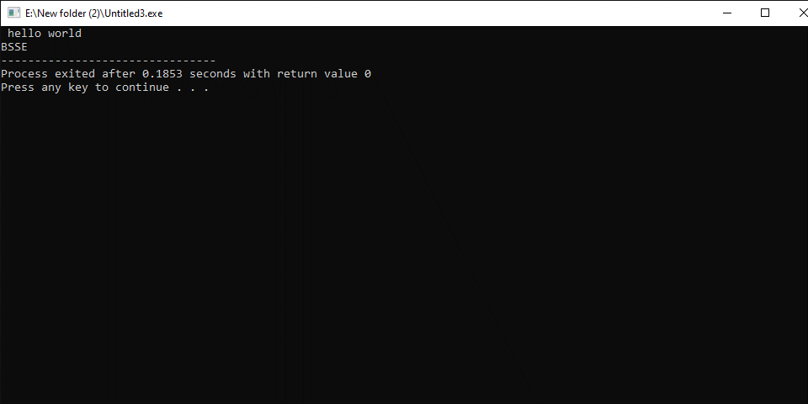

Write a program that print your Introduction.
#include<iostream>
using namespace std;
main()
{
cout<<”my name is zulqarnain hassan”<<endl;
cout<<”I am from skardu”<<endl;
cout<<”I got 80% in fsc”;
}
OUTPUT:-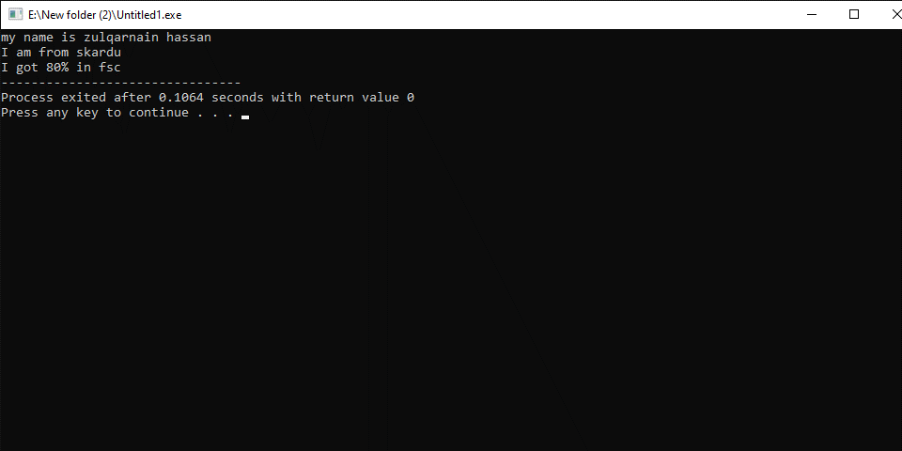

NATIONAL UNIVERSITY OF MODERN LANGUAGES
Program fundamental Lab report # 2

SUBMITTED BY:
ZULQARNAIN HASSAN

SUBMITTED TO:
SIR AAQIB ADEEL
Roll No : SP21379
Faculty: Engineering and computer science
Department: Software engineering
Section: BSSE-1-A-afternoon

Date 22-02-2022
Topics
- Assignment operator
- Arithmetic operator
- \n and \t
- Int, float, double, string, char, bool
Assignment operator:
The assignment operator is used to assign values to variables.
Assignment operator: “=”.
Variable=expression.
For example
- A=b+c.
- B=123.

Arithmetic operator:
The arithmetic operator is used to perform arithmetic operations on variables and data.
Arithmetic operator:
+ addition
_ subtraction
* Multiplication
/ Division
% Modulo operator
For example
A=34+g f=a-b
B=3*6 c=a+b/4
D= 20%4
\n and \t:
- \n is used to shifting to a new line.
- \t is used to give a tab space.

Int, float, double, string, char, bool.
- Int is used to store integers.
- Float is used to store decimal numbers with single precision.
- Double is used to store decimal numbers with double precision.
- A string is used to store a group of characters.
- Char is used to storing a character.
- Bool refers to a system of logical thought that is used to create true/false statements.

Write a program that assign an integer number in a variable and print it
#include<iostream>
using namespace std;
main()
{
int a;
a=10
cout<<a;
}
OUTPUT:-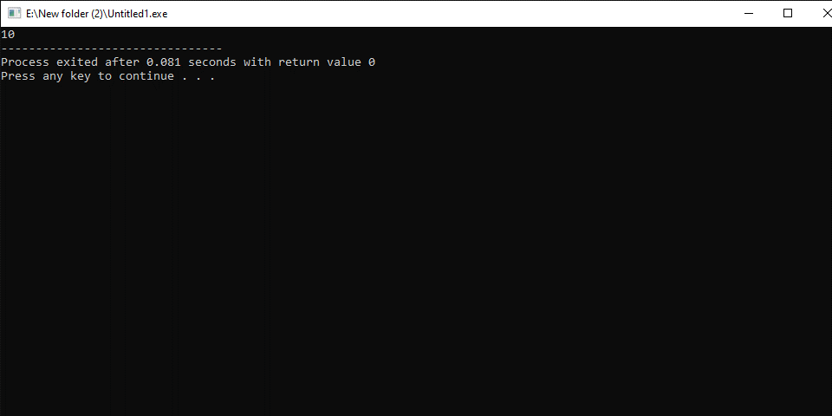
Write a program that assign two decimal number in a variable and print it
#include<iostream>
Using namespace std;
Main()
{
Float a,b;
a=12.5;
b=12.32;
cout<<a<<b;
}
OUTPUT:-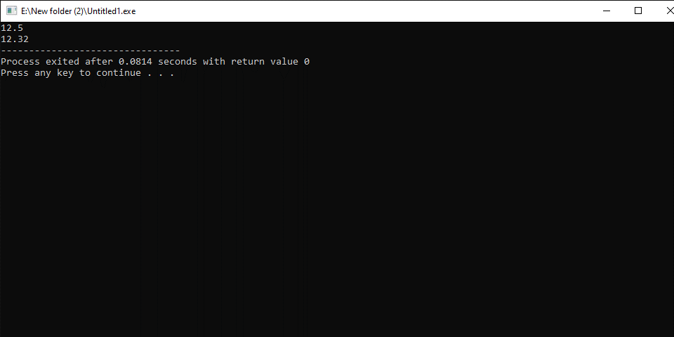
Write a program that assigns decimal numbers in variables and print them

#include<iostream>
using namespace std;
main()
{
double a=21.32451,b=23.4565,c=3.456223;
float d=32.4563,e=32.445;
cout<<a<<endl;
cout<<b<<endl;
cout<<c<<endl;
cout<<d<<endl;
cout<<e<<endl;
}
OUTPUT:- 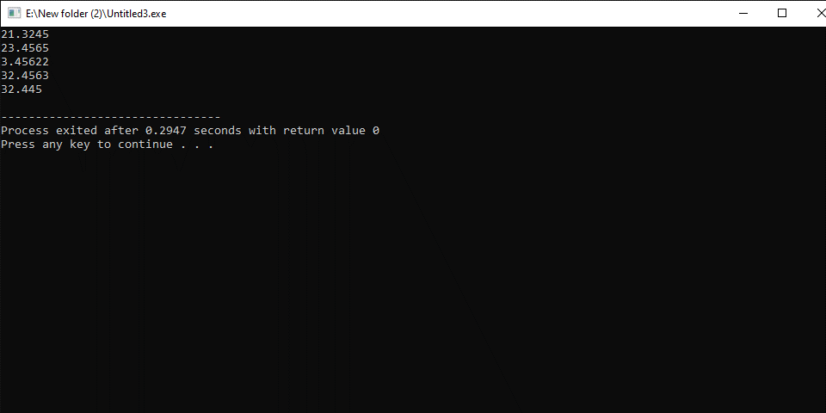
Write a program that assigns a character in a variable and print it

4 #include<iostream>
using namespace std;
main()
{
char a;
a=’g’;
cout<<a;
}OUTPUT: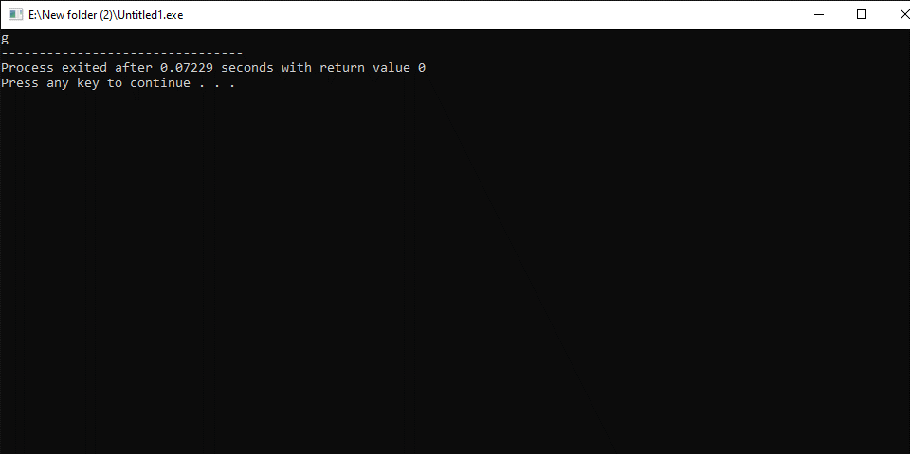

Write a program that assigns a string in a variable and print it
#include<iostream>
using namespace std;
main()
{
string a;
a="Ahmed";
cout<<a;
}
OUTPUT:-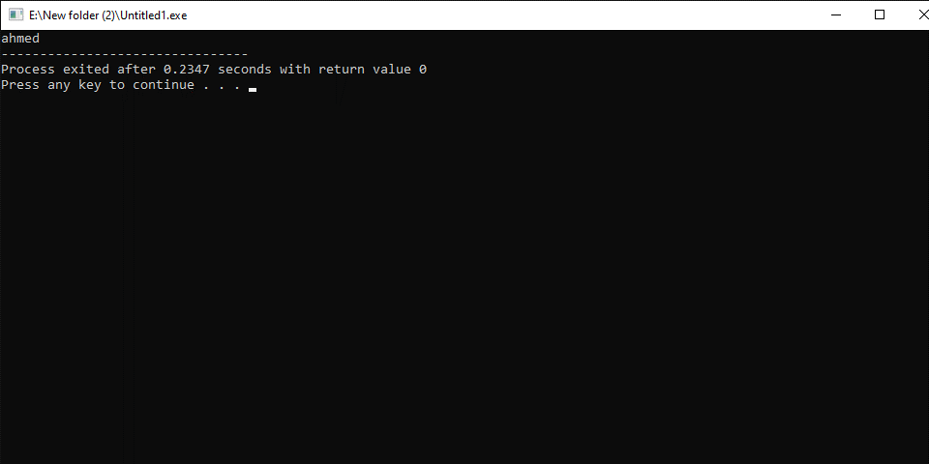
Write a program that print “ahmad call ali” using string
#include<iostream>
using namespace std;
main()
{
string a,b;
a="Ahmed";
b="ali";
cout<<a<<" call "<<b;
}
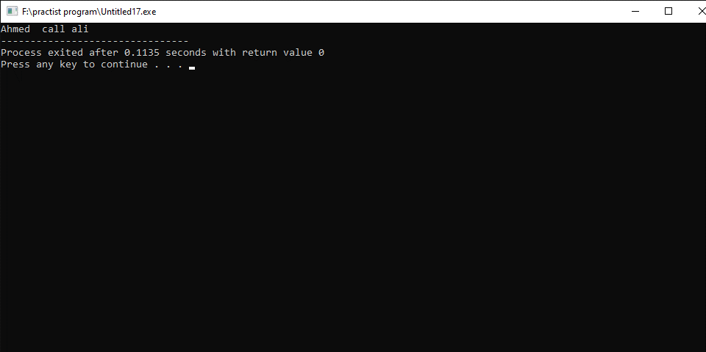
Write a program that assign two numbers in variables and print thir sum

6 #include<iostream>
using namespace std;
main()
{
int a,b,sum;
a=12;
b=13;
sum=a+b;
cout<<sum;
}

OUTPUT:-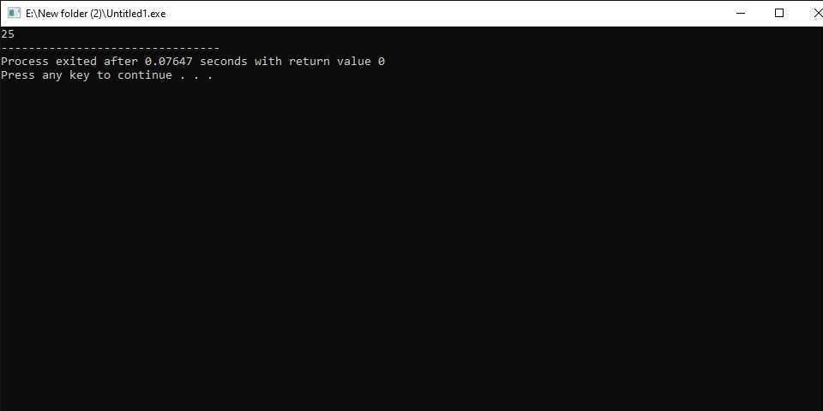
Write a program that assigns four numbers in variables and prints their sum, average, and product

#include<iostream>
#include<cmath>
using namespace std;
main()
{
int a,b,c,d,sum,average,product;
a=12;
b=13;
c=45;
d=19;
sum=a+b+c+d;
average=sum/4;
product=a*b*c*d;
cout<<"sum="<<sum<<"\n";
cout<<"average="<<average<<"\n";
cout<<"product="<<product<<"\n";

}
OUTPUT:-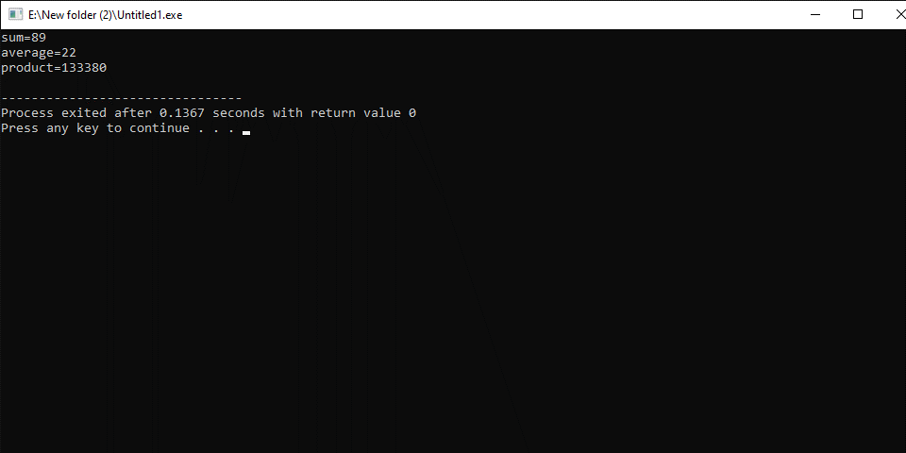
Write a program that performs the following operations
If a=12
b=a+43,c=b+34,d=a+c+3,a=b+c+d

#include<iostream>
#include<cmath>
using namespace std;
main()
{
Int a,b,,c,d;
a=12;
b=a+43;
c=b+34;
d=a+c+3;
a=b+c+d;
cout<<”a= ”<<a\n;
cout<<”b= ”<<b;
cout<<”c= ”<<c;
cout<<”d= ”<<d;
}

OUTPUT:-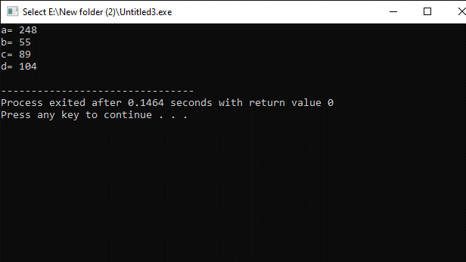

NATIONAL UNIVERSITY OF MODERN LANGUAGES
Program fundamental Lab report # 3

SUBMITTED BY:
ZULQARNAIN HASSAN

SUBMITTED TO:
SIR AAQIB ADEEL
Roll No : SP21379
Faculty: Engineering and computer science
Department: Software engineering
Section: BSSE-1-A-afternoon

Date 28-02-2022
Topics in the third week

- Calculate the area of the rectangle if length and width are given.
- Calculate the area of a triangle if perpendicular and base are given.
- Calculate the area and circumference of a circle if the radius is given.
- Calculate sum, average, and percentage of a student’s marks of six subjects
- Convert rupee into the dollar, euro, and pound.
- Find hypotenuse if altitude and base are given.
- Calculate the perimeter of a rectangle.
- Calculate the third angle if two angles are given.

Program NO 1
Calculate the area of the rectangle if length and width are given.

#include<iostream>
#include<cmath>
using namespace std;
main()
{
int len,wid,area;
len=32;
wid=22;
area=len*wid;
cout<<"area="<<area;
}
OUTPUT:-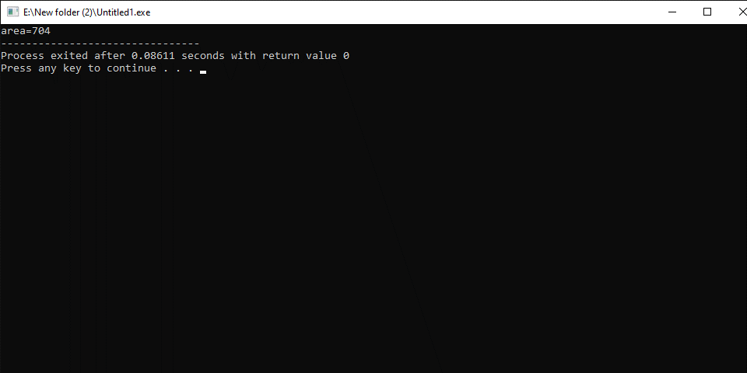

Program NO 2
calculate area of triangle if perpendicular and base are given.
#include<iostream>
#include<cmath>
using namespace std;
main()
{
int base,perp,area;
base=32;
perp=22;
area=base*perp;
cout<<"area of triangle is ="<<area;
}

OUTPUT:-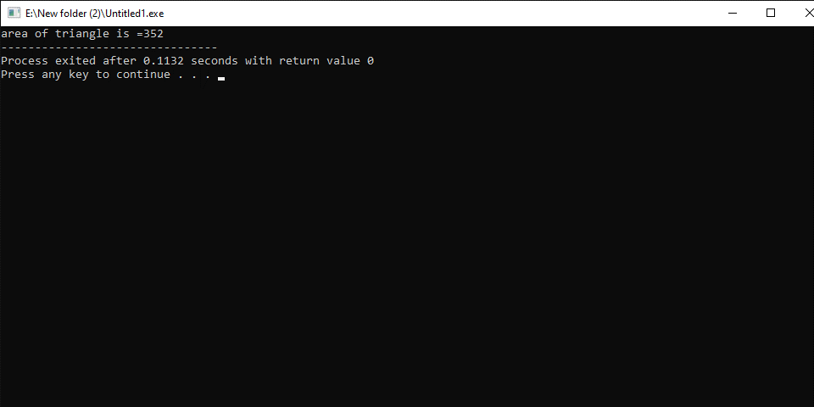

Program NO 3
Calculate the area and circumference of a circle if the radius is given.

#include<iostream>
#include<cmath>
using namespace std;
main()
{
int radius=10,area,circumference;
area=radius*radius*3.1415;
circumference=2*3.1415*radius;
cout<<"area="<<area<<endl<<"circumference="<<circumference;
}
OUTPUT:-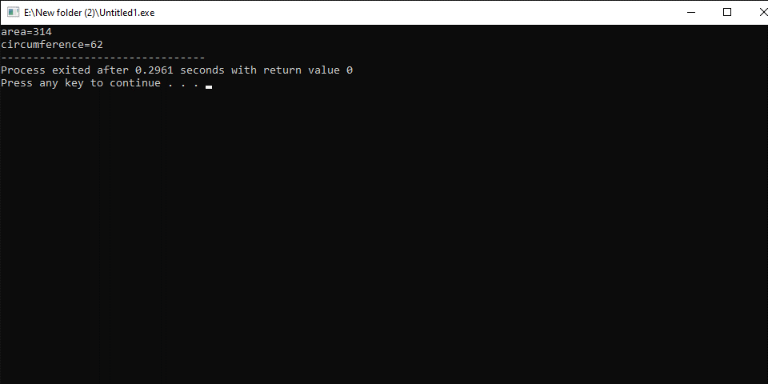

Program NO 4
Calculate sum, average and percentage of a student marks of six subjects.
#include<iostream>
#include<cmath>
using namespace std;
main()
{
int total=600,sub1,sub2,sub3,sub4,sub5,sub6,sum,average,percentage;
sub1=64;
sub2=79;
sub3=34;
sub4=67;
sub5=90;
sub6=65;
sum=sub1+sub2+sub3+sub4+sub5+sub6;
average=sum/6;
percentage=100*sum/total;
cout<<"sum="<<sum<<endl<<"average="<<average<<endl<<"percentage="<<percentage;
}
OUTPUT:-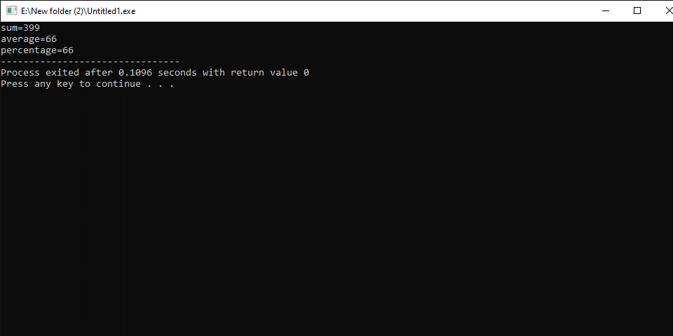
Program NO 5

Convert rupee into doller, euro and pound
#include<iostream>
#include<cmath>
using namespace std;
main()
{
double rupee,doller,euro,pound;
rupee=500;
doller=500/177.25;
euro=500/193.66;
pound=500/234.41;
cout<<"doller="<<doller<<endl<<"euro="<<euro<<endl<<"pound="<<pound;
}
OUTPUT:-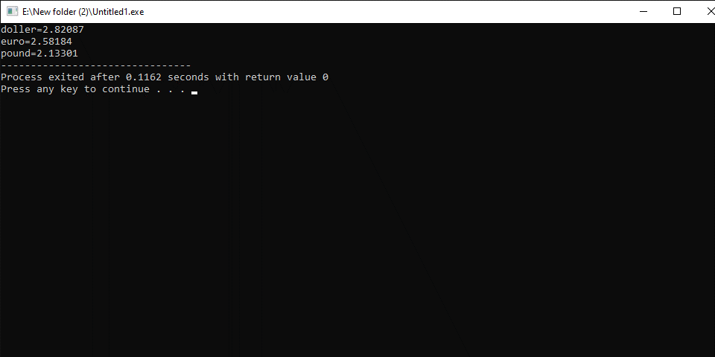
Program NO 6

Find hypotenuse if altitude and base are given.
#includ<iostream>
#include<cmath>
using namespace std;
main()
{
int alt,base,hyp;
alt=32;
base=22;
hyp=sqrt((alt*alt)+(base*base));
cout<<"hyp="<<hyp;
}
OUTPUT:- 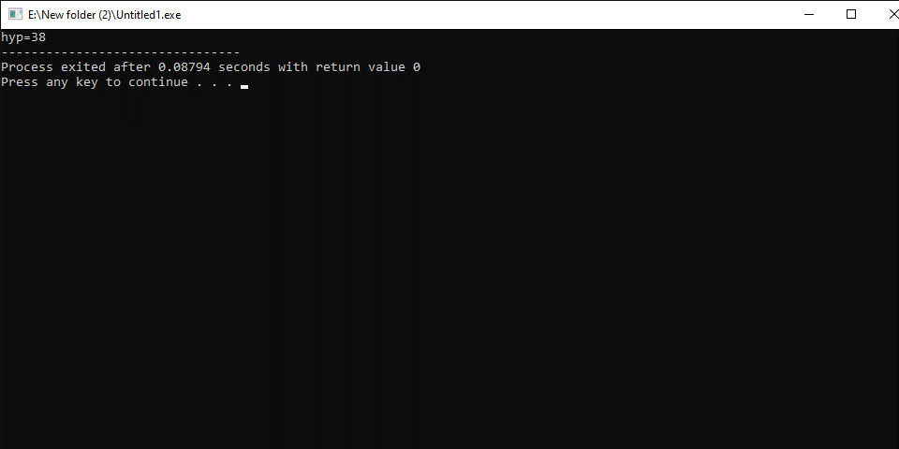

Program NO 7
Calculate the perimeter of a rectangle.
#include<iostream>
using namespace std;
main()
{
int len,wid,perimeter;
len=40;
wid=30;
perimeter=2*(len+wid);
cout<<"perimeter of rectangle is = "<<perimeter;
}

OUTPUT:- 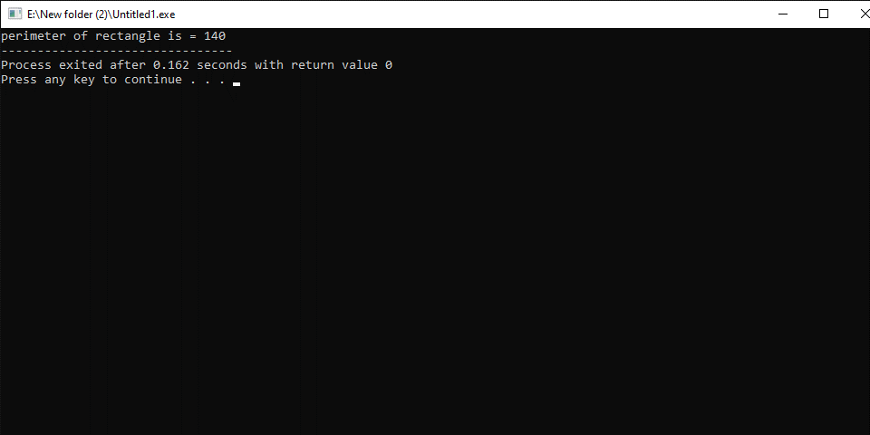
Program NO 8
Calculate the third angle of a triangle if two angles are given.

#include<iostream>
using namespace std;
main()
{
int angle1,angle2,angle3;
angle1=90;
angle2=30;
angle3=180-angle1-angle2;
cout<<"angle3="<<angle3;
}

OUTPUT:-
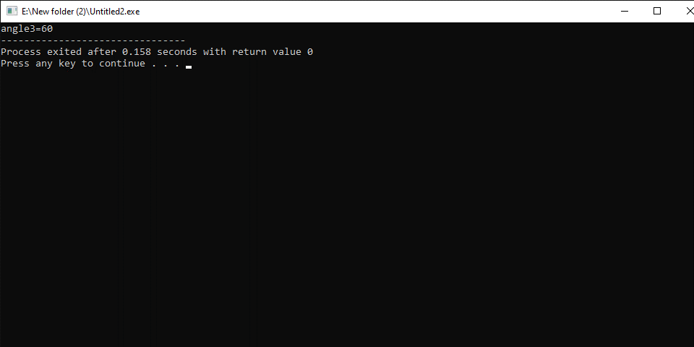

NATIONAL UNIVERSITY OF MODERN LANGUAGES
Program fundamental Lab report # 4

SUBMITTED BY:
ZULQARNAIN HASSAN

SUBMITTED TO:
SIR AAQIB ADEEL
Roll No : SP21379
Faculty: Engineering and computer science
Department: Software engineering
Section: BSSE-1-A-afternoon

Date 07-03-2022
- cin.
- Unary operator.
- Binary operator.
- Ternary operator.
- If statement.
- Multiple If statement.
- Nested if statement.
- If-else statement.
- Else-if statemen.

Cin:
The cin object is used to accept input from the user.
Unary operator:
The operator that works on a single operand is known as a unary operator.
Some examples of unary operators are.
A=b++
B=-a
--x
Binary operator:
The operator that works on two operators is known as the binary operator.
Some examples of binary operators are.
A=b-c
V=a*b
V=b%e
Ternary operator:
The conditional operator (? :) is known as the ternary operator since it has three parts. These three parts are a condition and two expressions. The condition is evaluated and based on its result one of the expressions is executed.
If statement:
The if statement is used to execute a block of statements based on a condition.
Syntax
If(condition)
{
Block of statements
}
Multiple IF statements:
If we using more than one if statement in a function called multiple if statement.
Syntax
If(condition)
{
Block of statements
}
If(condition)
{
Block of statements
}……….
Nested-If statement
if statement inside another if statement is called nested if statement.
Syntax
If(condition)
{
If(condition)
{
body
}
}
If-else statement:
If else allows making decision between two courses of action based on a condition.
The following is the general form of if-else statement.
If(condition)
{
Block of statement.
}
else
{
Block of statement.
}
else –If statement:
The else if statement is used in situation where a decision is to be make from several alternatives based on various conditions.
If(condition)
{
Block of statement 1
}
Else if(condition)
{
Block of statement 2
}
.
.
.
Else
{
Block of statement- n
}

Write a program that get the length and width of a rectangle and print its area
#include<iostream>
using namespace std;
main()
{
int len,wid,area;
cout<<"enter length ";
cin>>len;
cout<<"enter width ";
cin>>wid;
area=len*wid;
cout<<"area="<<area;
}

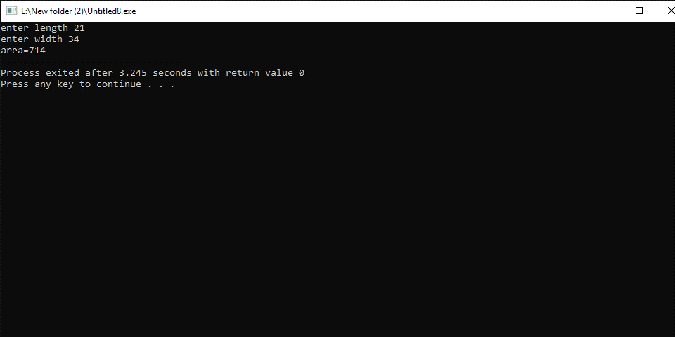

Write a program that get two angles of a triangle and print its third angle

#include<iostream>
using namespace std;
main()
{
int a1,a2,a3;
cout<<"enter two angles ";
cin>>a1>>a2;
a3=180-a1+a2;
cout<<"third angle "<<a3;
}
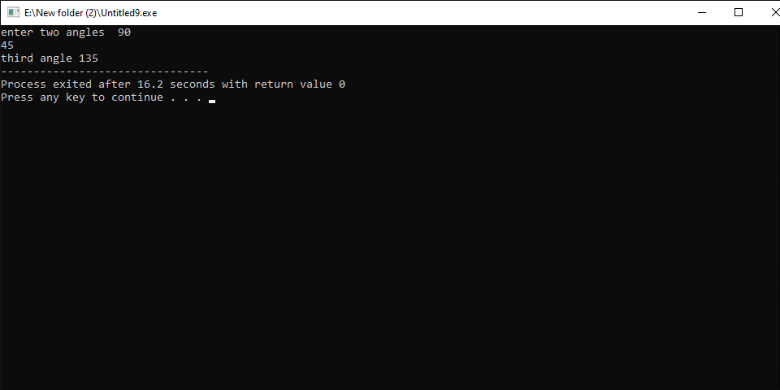
Write a program that get radius from the user and print its circumferance
#include<iostream>
using namespace std;
main()
{
float r,c;
cout<<"enter radius ";
cin>>r;
c=2*3.1444*r;
cout<<"circumferance = "<<c;
}
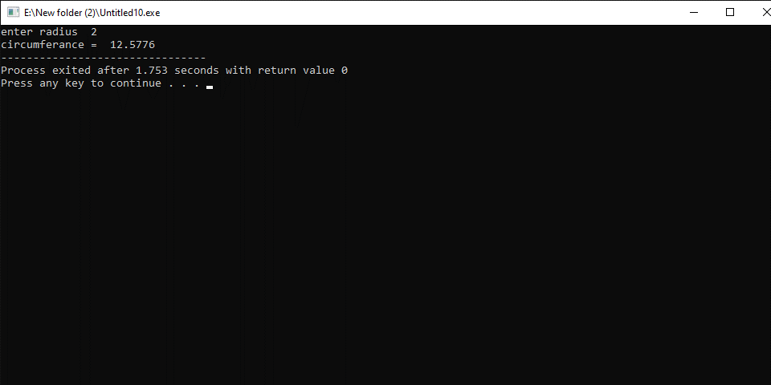
Write a program that get a number and print with an increment
#include<iostream>
using namespace std;
main()
{
int a;
cin>>a;
cout<<"a="<<a++;
cout<<"\na-"<<a;
}
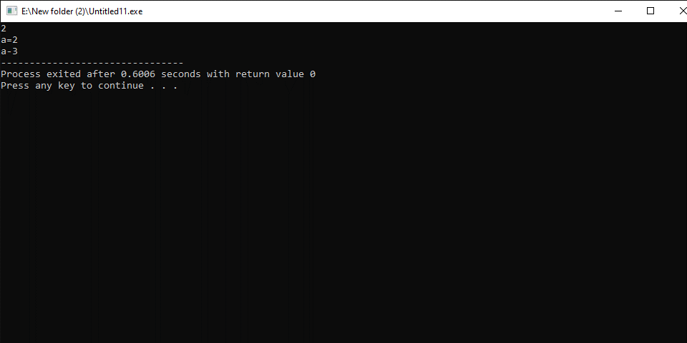
Write a program that get a number and print with a decrement

#include<iostream>
using namespace std;
main()
{
int a;
cin>>a;
cout<<"a="<<a--;
cout<<"\na-"<<a;
}
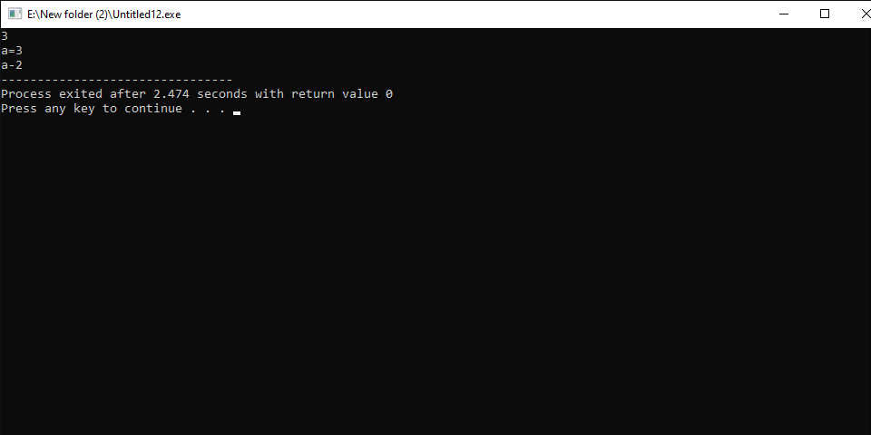
Write a program that get a number and print with an increment

#include<iostream>
using namespace std;
main()
{
int a,b;
cin>>a;
cout<<"a="<<--a;
b=++a;
cout<<"\na="<<b;
}
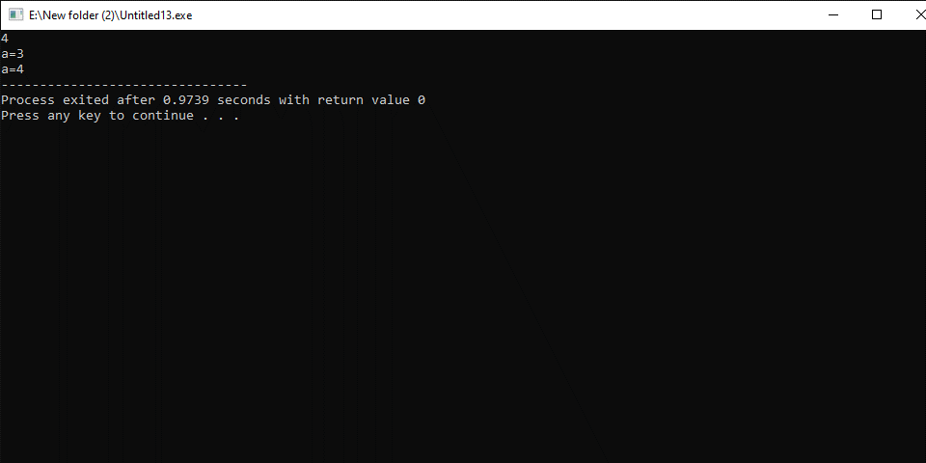

Write a program that get the age from user and print “you can have CNIC” if age is greater then 18.

#include<iostream>
using namespace std;
main()
{
int age;
cout<<"enter your age ";
cin>>age;
if(age>18)
{
cout<<"you can have CNIC";
}
}
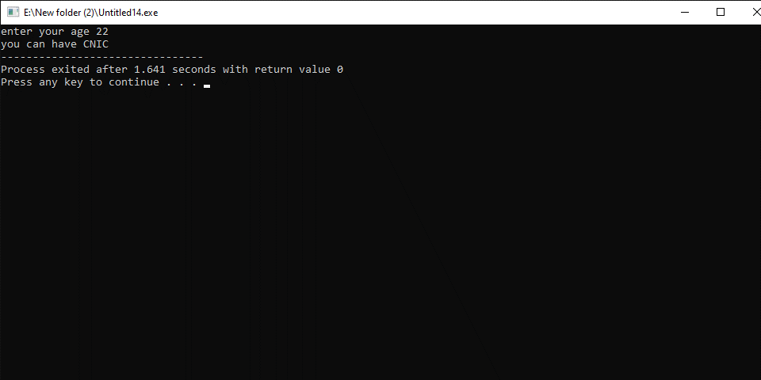
Write a program that ask the user to guess a number and if number is equale to 18 then print “you guess the right number ”

#include<iostream>
using namespace std;
main()
{
int num;
cout<<"enter a number ";
cin>>num;
if(num==18)
{
cout<<"you guess the right number";
}
}
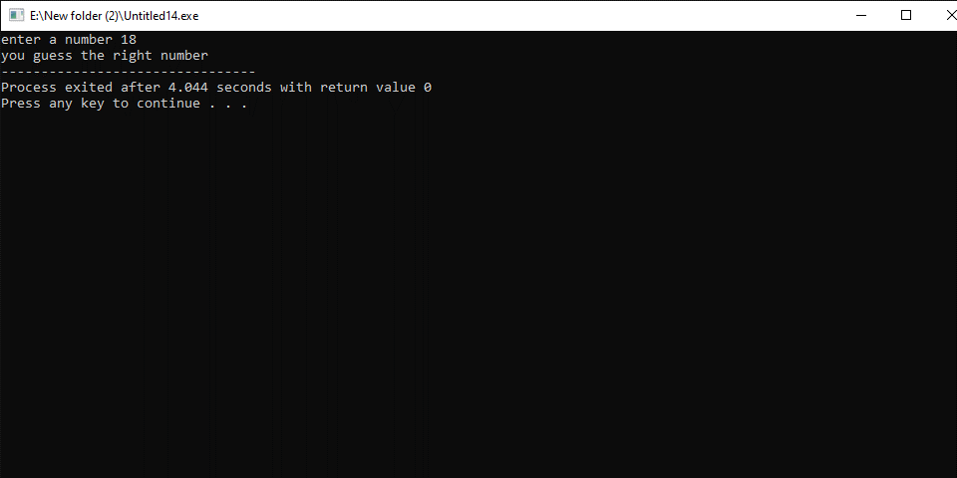

Write a program that get a number from user and if the number is divisible by 3 then print number is divisible by 3
#include<iostream>
using namespace std;
main()
{
int num;
cout<<"enter a number ";
cin>>num;
if(num%3==0)
{
cout<<num<<" is divisible by 3";
}
}
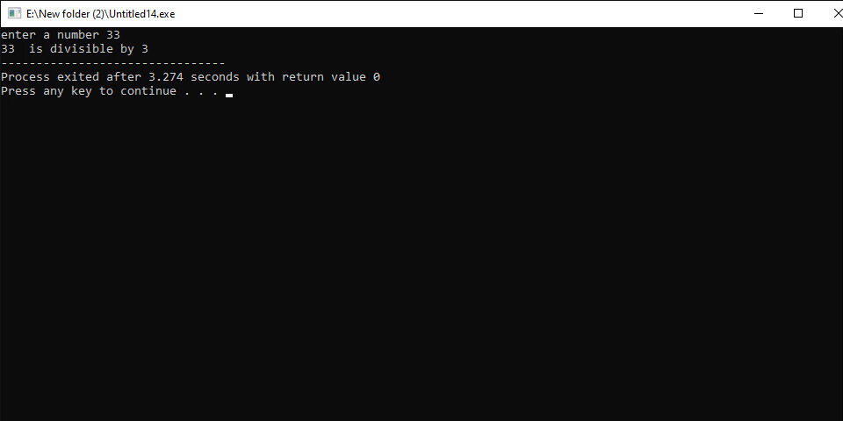
Write a program that read two numbers. If the first number is a positive number then it will print the sum of the two numbers.
#include<iostream>
using namespace std;
main()
{
int n1,n2,sum;
cout<<"enter a number ";
cin>>n1;
cout<<” enter anither number”;
cin>>n2
if(n1%2==0)
{
Sum=n1+n2;
cout <<" sum= "<<sum;
}
}
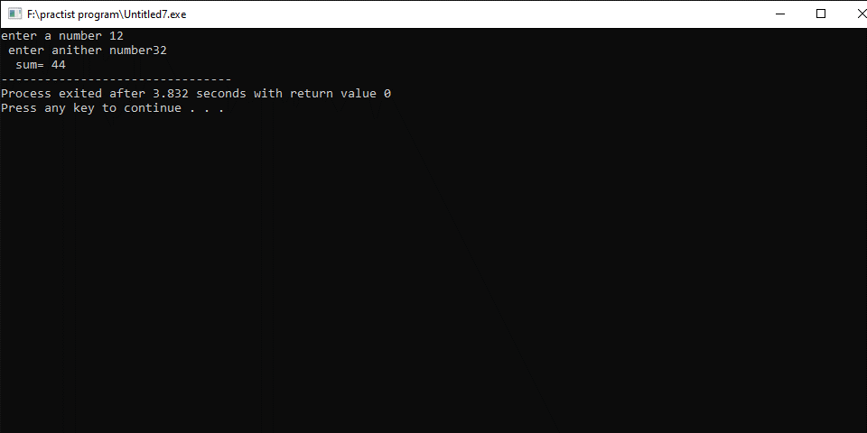

Write a program that get a number from user and if the number is divisible by 5 then print number is divisible by 5

#include<iostream>
using namespace std;
main()
{
int num;
cout<<"enter a number ";
cin>>num;
if(num%5==0)
{
cout<<num<<" is divisible by 5";
}
}
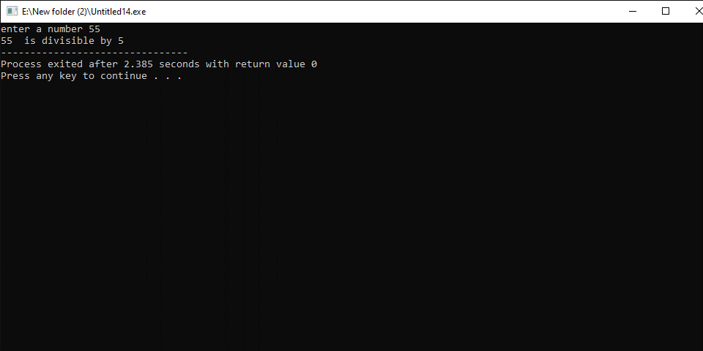
Write a program that get a number from user and perform the following operation
b=a-2;
c=b*a*4+b;
d=c*a+12*d;
a=c*d-a*d+12;
e=d-d*a-a*b-b;
f=a+e-b*c;
a=a*f;
b=a+b+c+d+f;

#include<iostream>
using namespace std;
main()
{
int a,b,c,d,e,f;
cin>>a;
b=a-2;
c=b*a*4+b;
d=c*a+12*d;
a=c*d-a*d+12;
e=d-d*a-a*b-b;
f=a+e-b*c;
a=a*f;
b=a+b+c+d+f;
cout<<"\na= "<<a<<"\nb= "<<b<<"\nc= "<<c<<"\nd= "<<d<<"\ne= "<<e<<"\nf= "<<f;
}
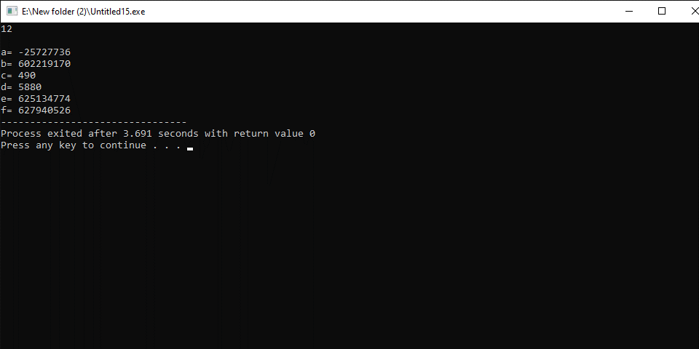

Write a program that read the section from the user and prints the room number if the section is A then room 42 and if the section is B then room 43.
#include<iostream>
Using namespace std;
Main()
{
Char section;
Cout<<”enter your section”;
Cin>>section;
If(section==A)
{
Cout<<”your section is room no 42”;
}
If(section==B)
{
Cout<<” your section is room no 43”;
}
}

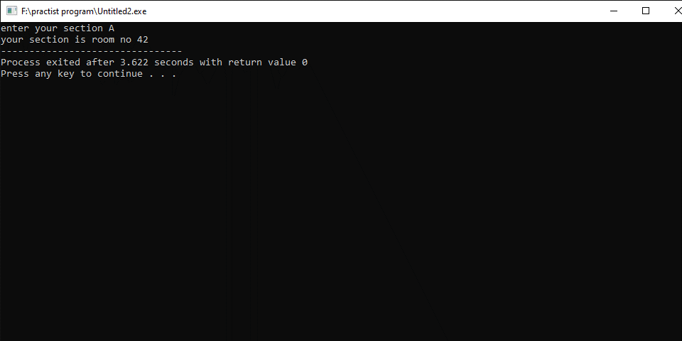
Write a program that gets three numbers from the user and print the greatest number
#include<iostream>
using namespace std;
main()
{
int a,b,c;
cout<<"enter three number";
cin>>a>>b>>c;
cout<<"a= "<<a<<"\n b= "<<b<<"\n c= "<<c<<endl;
if(a>b)
{
if(a>c)
{

cout<<a<<" is greatest";
}
}
if(b>a)
{
if(b>c)
{
cout<<b<<" is greatest";
}
}
if(c>a)
{
if(c>b)
{
cout<<c<<" is greatest";
}
}
}
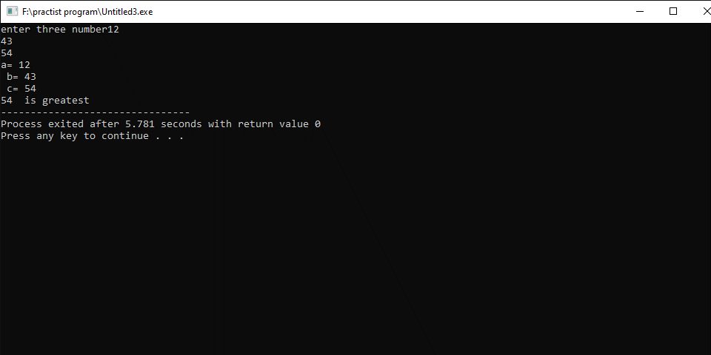
Write a program that read a three-digit number from the user and prints its last digit.
#include<iostream>
using namespace std;
main()
{
int num,digit;
cout<<”enter three digit number”;
cin>>num;
digit=num%10;
cout<<digit<<” is the last digit”;
}
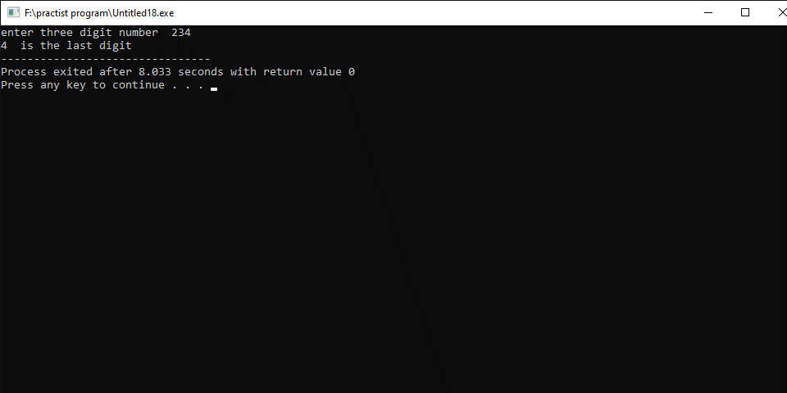
Write a program that read a number between 1 and 10 and print as:
- Number > 7 : print too high.
- umber < 7 :print too less.
- number =7 : you guess the write number
- other wice invalide
#include<iostream>
Using namespace std;
Main()
{
int num;
Cout<<”guess a number”;
Cin>>num;
If(num<=10)
{
If(num>=0)
{
If(num<7)
{
cout<<” too low”;
}
If(num>7)
{
Cout<<” too high”;
}
Else
{
Cout<<”you guess the right number”;
}
}
}
}

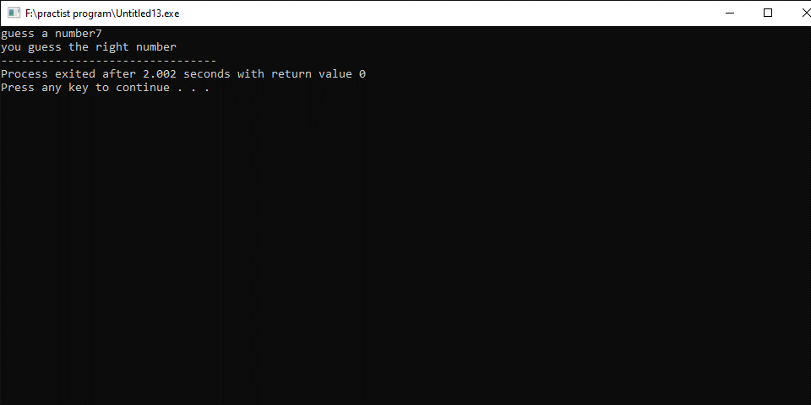
Write a program that read a number and print as
- 1 is fector of n
- 2 is fector of n and so on up to 10.
#include<iostream>
Using namespace std;
Main()
{
Int n;
Cout<<” enter a number”;
Cin>>n;
If(n%1==0)
{
Cout<<”\n 1 is fector of ”<<n;
}
If(n%2==0)
{
Cout<<”\n 2 is fector of ”<<n;
} If(n%3==0)
{
Cout<<”\n 3 is fector of ”<<n;
} If(n%4==0)
{
Cout<<”\n 4 is fector of ”<<n;
} If(n%5==0)
{
Cout<<”\n 5 is fector of ”<<n;
} If(n%6==0)
{
Cout<<”\n 6 is fector of ”<<n;
} If(n%7==0)
{
Cout<<”\n 7 is fector of ”<<n;
} If(n%8==0)
{
Cout<<”\n 8 is fector of ”<<n;
} If(n%9==0)
{
Cout<<”\n 9 is fector of ”<<n;
} If(n%10==0)
{
Cout<<”\n 10 is fector of ”<<n;
}
}
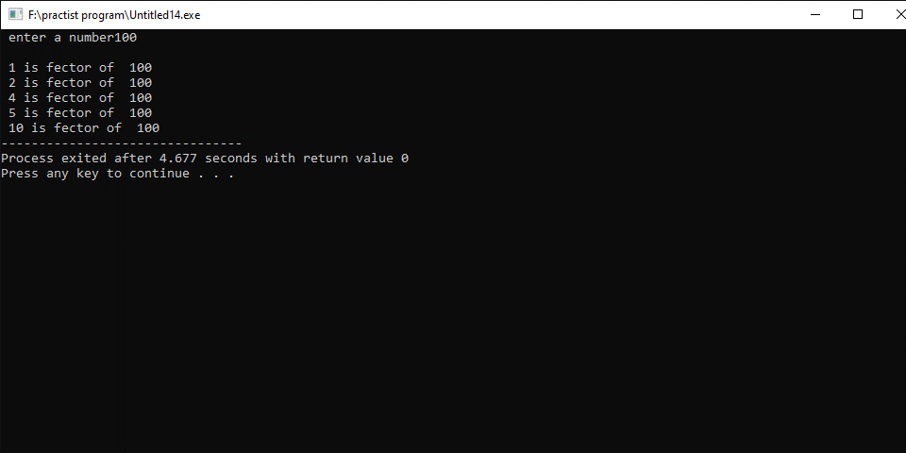
Write a program that read your salary and print as:
If salary=50000 then tex=45%
If salary>50000 then tex=70%
If salary<50000 then tex=35%
#include<iostream>
using namespace std
main()
{
int salary,tex;
cout<<”enter your salary”;
cin>>salary;
if(salary==50000)
{
tex=50000*45/100;
cout<<”tex is= ”<<tex;
cout<<”\nnow your salary is = ”<<salary-tex;
}
if(salary>50000)
{
tex=50000*70/100;
cout<<”tex is= ”<<tex;
cout<<”\nnow your salary is = ”<<salary-tex;
}
if(salary<50000)
{
tex=50000*35/100;
cout<<”tex is= ”<<tex;
cout<<”\nnow your salary is = ”<<salary-tex;
}
}
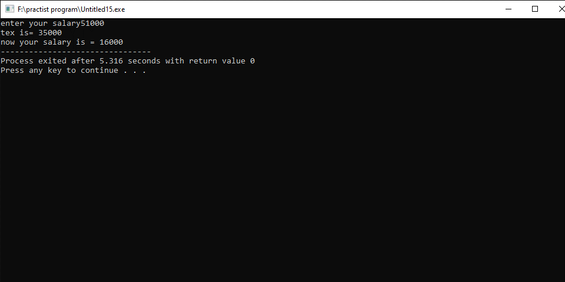

Write a program that read a number and print whether it is even or odd number.
#include<iostream>
Using namespace std;
Main()
{
Int num;
Cin>>num;
If(num%2==0)
Cout<<”num is even”;
Else
Cout<<”num is odd”;
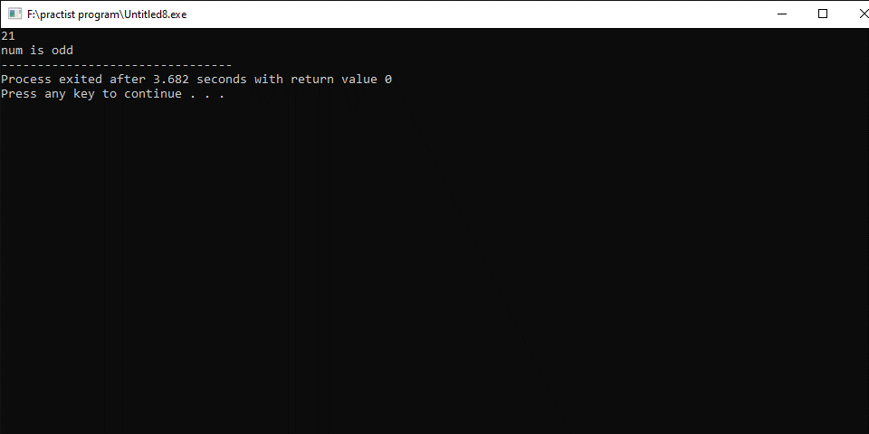}
Write a program that read a number and prints whether it is multiple of three or not.
#include<iostream>
Using namespace std;
Main()
{
Int a;
Cin>>a;
If(a%3==0)
Cout<<a<<” is multiple of three”;
Else
Cout<<a<<” is not multiple of three”;
}
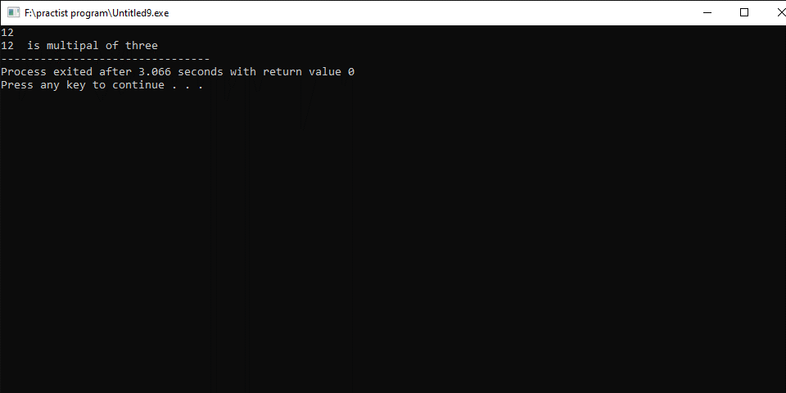
Write a program that reads a section of the student and print room 42 if section is A other wice room 43.
#include<iostream>
Using namespace std;
Main()
{
Char section;
Cin>>section;
If(section==A)
{
Cout<<” room 42”;
}
Else
{
Cout<<” room 43”;
}
}

Write a program that read a number from user and print whether it is positive, negative or it is equel to zero.
#include<iostream>
Using namespace std;
Main()
{
Int num;
Cin>>num;
If(num>0)
{
Cout<<num<<” is positive”;
}
Else if(num<0)
{
Cout<<num<<” is negative”;
}
Else
{
Cout<<num<<” is equal to zero”;
}
}
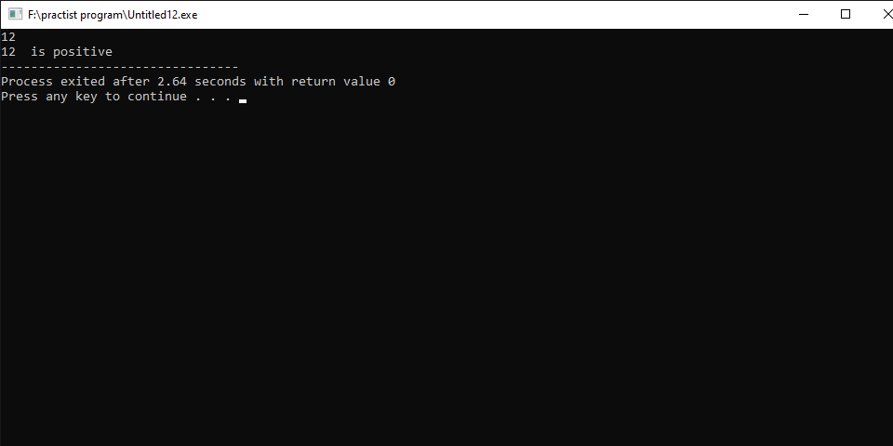
Write a program that read the marks from user and print the grade based on the mark obtained.
#include<iostream>
Using namespace std;
Main()
{
Int mark;
Cin>>mark;
If(mark<=100)
{
If(mark>=80)
{
Cout<<”grade A”;
}
If(mark>=80)
{
Cout<<”grade A”;
}
Else If(mark>=70)
{
Cout<<”grade B”;
}
Else If(mark>=60)
{
Cout<<”grade C”;
}
Else If(mark>=50)
{
Cout<<”grade D”;
}
Else If(mark<50)
{
Cout<<”fail”;
}

}
Else
Cout<<”invalide”;
}
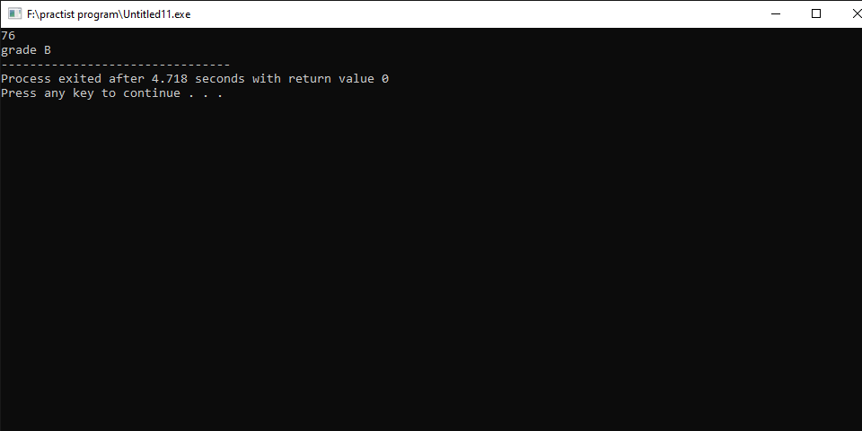

Write a program thet read salary of the user and print output as.
If salary=50000: allowance=7%
If salary<50000: allowance=3.5%
If salary>50000: allowance=9%
#include<iostream>
using namespace std;
main()
{
float salary,allowance;
cout<<”enter your salary”;
cin>>salary;
if(salary==50000)
{
allowance=salary*7/100;
cout<<”allowance is =”<<allowance;
cout<<”\nsalary is now”<<salary+allowance;
}
if(salary>50000)
{
allowance=salary*9/100;
cout<<”allowance is =”<<allowance;
cout<<”\nsalary is now”<<salary+allowance;
}
if(salary<50000)
{
allowance=salary*3.5/100;
cout<<”allowance is =”<<allowance;
cout<<”\nsalary is now”<<salary+allowance;
}

}
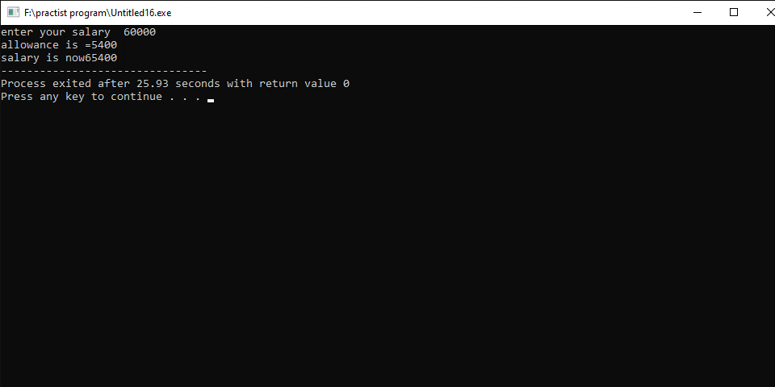

NATIONAL UNIVERSITY OF MODERN LANGUAGES
Program fundamental Lab report # 5

SUBMITTED BY:
ZULQARNAIN HASSAN

SUBMITTED TO:
SIR AAQIB ADEEL
Roll No : SP21379
Faculty: Engineering and computer science
Department: Software engineering
Section: BSSE-1-A-afternoon

Topics
- Loops:-
- For Loop
- Nested Loop
- Nested for loop

- Loop:
In computer programming, loops are used to repeat a block of code.
we can achieve much more efficiency and sophistication in our programs by making effective use of loops.

Types of loop
- For loop:
A for loop is a repetition control structure that allows you to efficiently write a loop that needs to execute a specific number of times.
Syntax
for (initialization; condition; update)
{
// body of-loop
}

- Nested for loop
If a for loop exists inside the body of another for loop, it's called a nested for loop.
Syntax
for (int i = 1; i <= 5; ++i)
{

for(int j = 1; j <=2; ++j)
{
// codes
} ..
}

Write a program in C++ to find the first 10 natural numbers.
#include <iostream>
using namespace std;
main()
{
int i;
cout << "\n\n Find the first 10 natural numbers:\n";
cout << " The natural numbers are: \n";
for (i = 1; i <= 10; i++)
{
cout << i << " ";
}
cout << endl;
}
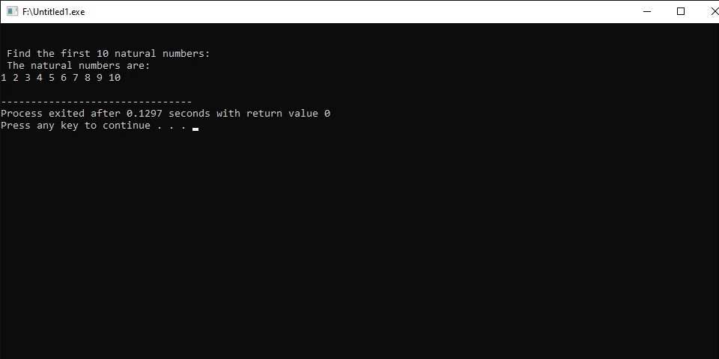

Write a program in C++ to find the sum of first 10 natural numbers.
#include <iostream>
using namespace std;
int main()
{
int i,sum=0;
cout << "\n\n Find the first 10 natural numbers:\n";
cout << "---------------------------------------\n";
cout << " The natural numbers are: \n";
for (i = 1; i <= 10; i++)
{
cout << i << " ";
sum=sum+i;
}
cout << "\n The sum of first 10 natural numbers: "<<sum << endl;
}
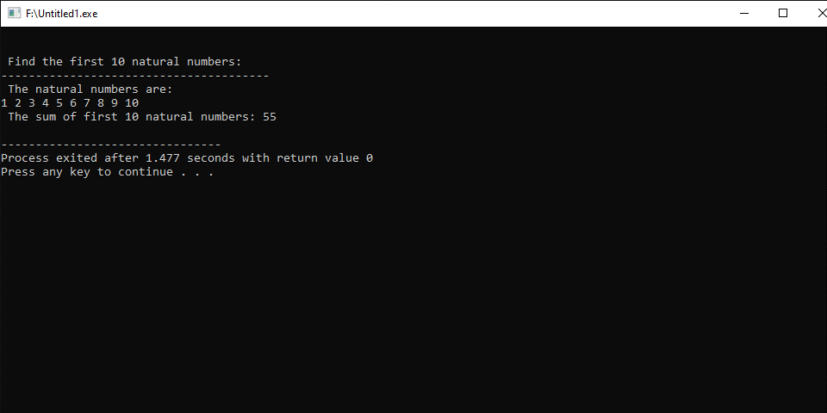
Write a program in C++ to display n terms of natural number and their sum.
#include <iostream>
using namespace std;
int main()
{
int n,i,sum=0;
cout << "\n\n Display n terms of natural number and their sum:\n";
cout << "---------------------------------------\n";
cout << " Input a number of terms: ";
cin>> n;
cout << " The natural numbers upto "<<n<<"th terms are: \n";
for (i = 1; i <= n; i++)
{
cout << i << " ";
sum=sum+i;
}
cout << "\n The sum of the natural numbers is: "<<sum << endl;
}
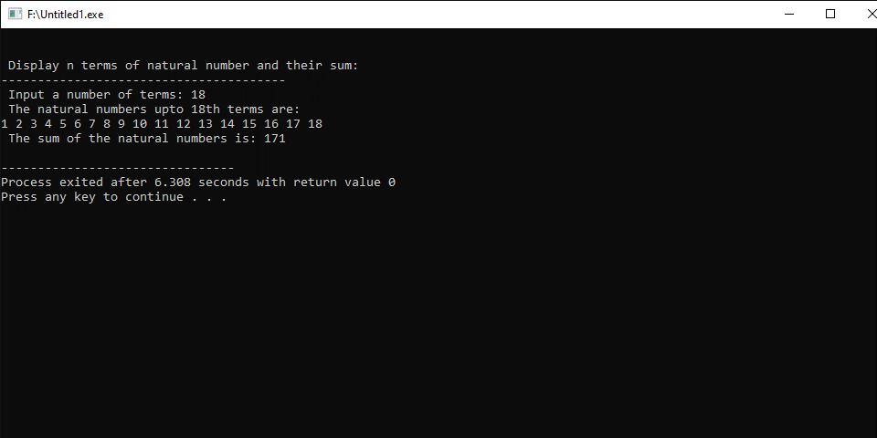
Write a program in C++ to find the perfect numbers between 1 and 500.
#include <iostream>
using namespace std;
int main()
{
cout << "\n\n Find the perfect numbers between 1 and 500:\n";
cout << "------------------------------------------------\n";
int i = 1, u = 1, sum = 0;
cout << "\n The perfect numbers between 1 to 500 are: \n";
while (i <= 500)
{
while (u <= 500)
{
if (u < i)
{
if (i % u == 0)
sum = sum + u;
}
u++;
}
if (sum == i) {
cout << i << " " << "\n";
}
i++;
u = 1;
sum = 0;
}
}
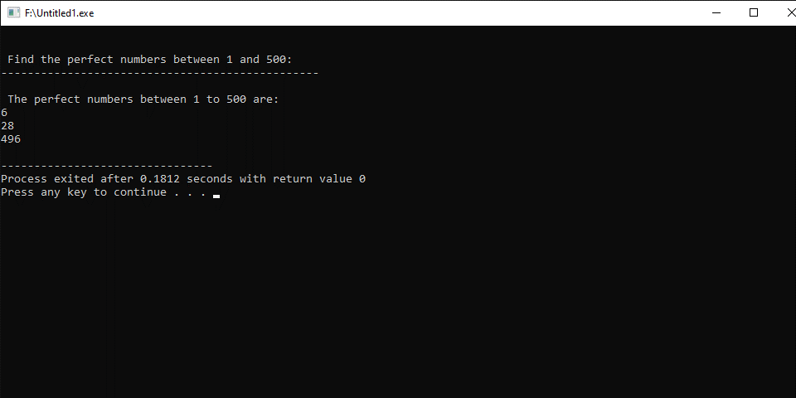
Write a program in C++ to check whether a number is prime or not.
#include <iostream>
using namespace std;
int main()
{
int num1, ctr = 0;
cout << "\n\n Check whether a number is prime or not:\n";
cout << "--------------------------------------------\n";
cout << " Input a number to check prime or not: ";
cin>> num1;
for (int a = 1; a <= num1; a++)
{
if (num1 % a == 0)
{
ctr++;
}
}
if (ctr == 2)
{
cout << " The entered number is a prime number. \n";
}
else {
cout << " The number you entered is not a prime number. \n";
}
}
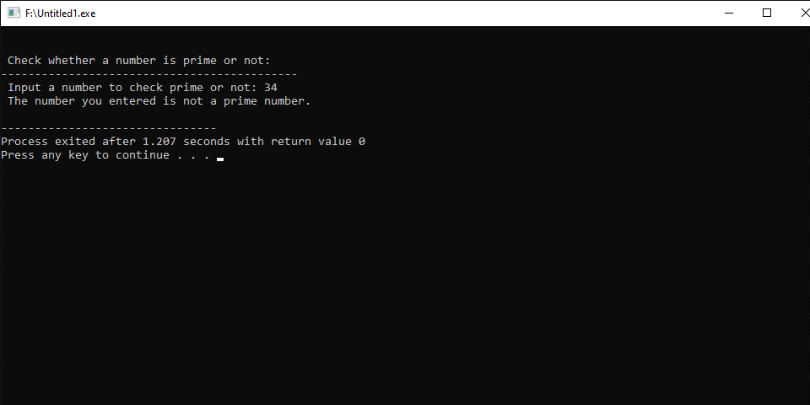
Write a program in C++ to find prime number within a range
#include <iostream>
#include<math.h>
using namespace std;
int main()
{
int num1,num2;
int fnd=0,ctr=0;
cout << "\n\n Find prime number within a range:\n";
cout << "--------------------------------------\n";
cout << " Input number for starting range: ";
cin>> num1;
cout << " Input number for ending range: ";
cin>> num2;

cout << "\n The prime numbers between "<<num1<<" and "<<num2<<" are:"<<endl;
for(int i=num1;i<=num2;i++)
{
for(int j=2;j<=sqrt(i);j++)
{
if(i%j==0)
ctr++;
}
if(ctr==0&&i!=1)
{ fnd++;
cout<<i<<" ";

}
ctr=0;
}
cout<<"\n\n The total number of prime numbers between "<<num1<<" to "<<num2<<" is: "<<fnd<<endl;
return 1;
}
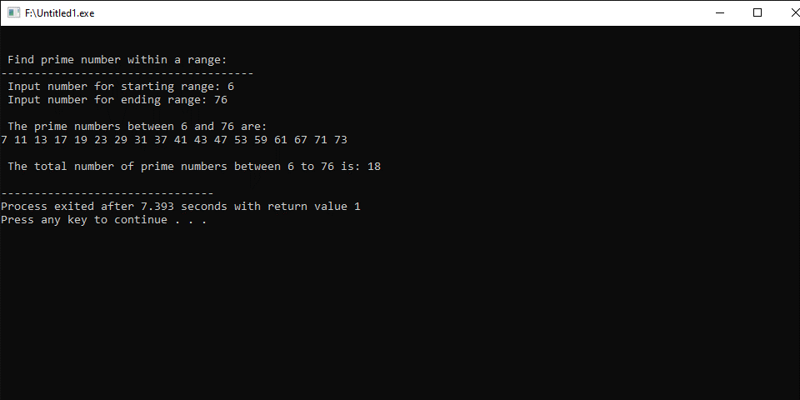
Write a program in C++ to find the factorial of a number.
#include <iostream>
using namespace std;
int main()
{
int num1,factorial=1;
cout << "\n\n Find the factorial of a number:\n";
cout << "------------------------------------\n";
cout << " Input a number to find the factorial: ";
cin>> num1;
for(int a=1;a<=num1;a++)
{
factorial=factorial*a;
}
cout<<" The factorial of the given number is: "<<factorial<<endl;
return 0;
}
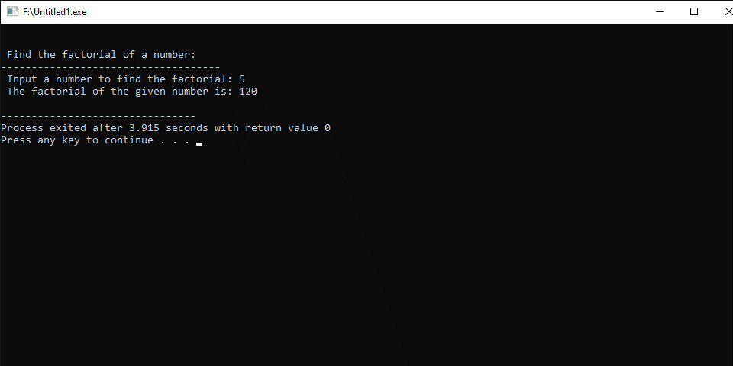
Write a program in C++ to find the last prime number occur before the entered number.
#include <iostream>
using namespace std;
int main()
{
int num1, ctr = 0;
cout << "\n\n Find the last prime number occurs before the entered number:\n";
cout << "-----------------------------------------------------------------\n";
cout << " Input a number to find the last prime number occurs before the number: ";
cin >> num1;
for (int n = num1 - 1; n >= 1; n--)
{
for (int m = 2; m < n; m++)
{
if (n % m == 0)
ctr++;
}
if (ctr == 0)
{
if (n == 1)
{
cout << "no prime number less than 2";
break;
}
cout << n << " is the last prime number before " << num1 << endl;
break;
}
ctr = 0;
}
return 0;
}
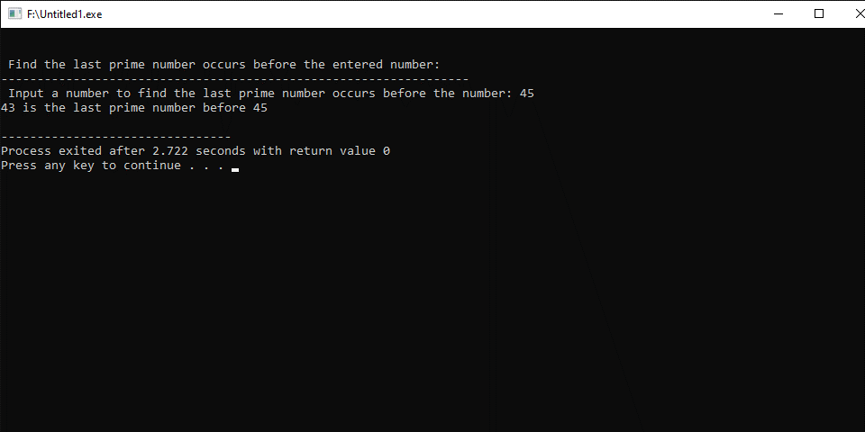
Write a program in C++ to find the Greatest Common Divisor (GCD) of two numbers.
#include <iostream>
using namespace std;
int main()
{
int num1, num2, gcd;
cout << "\n\n Find the Greatest Common Divisor of two numbers:\n";
cout << "-----------------------------------------------------\n";
cout << " Input the first number: ";
cin >> num1;
cout << " Input the second number: ";
cin >> num2;

for (int i = 1; i <= num1 && i <= num2; i++)
{
if (num1 % i == 0 && num2 % i == 0)
{
gcd = i;
}
}
cout << " The Greatest Common Divisor is: " << gcd << endl;
return 0;
}
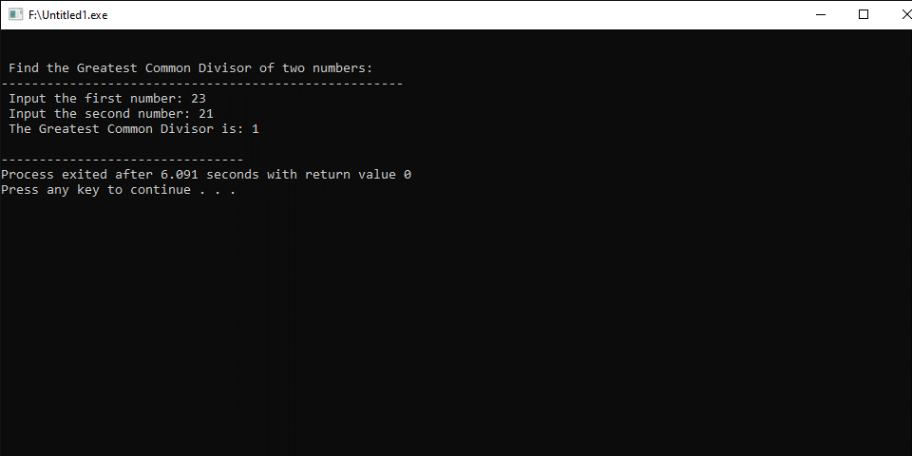
Write a program in C++ to find the sum of digits of a given number.
#include <iostream>
using namespace std;
int main()
{
int num1, num2, r, sum=0;
cout << "\n\n Find the sum of digits of a given number:\n";
cout << "----------------------------------------------\n";
cout << " Input a number: ";
cin >> num1;
num2 = num1;
while (num1 > 0)
{
r = num1 % 10;
num1 = num1 / 10;
sum = sum + r;
}
cout << " The sum of digits of " << num2 << " is: " << sum << endl;
}
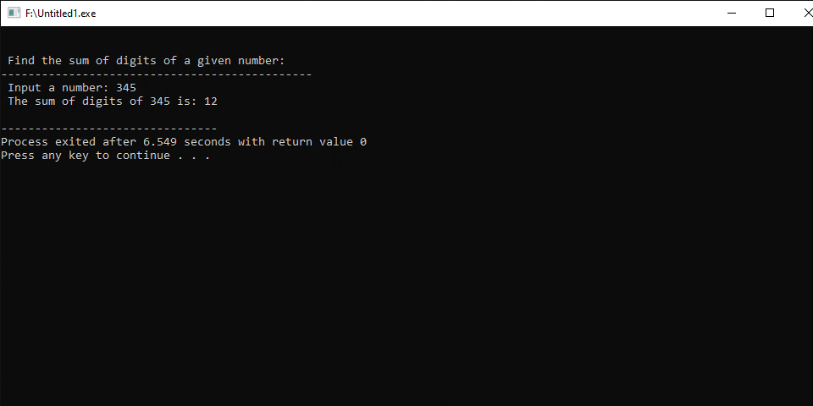

Write a program in C++ to calculate the sum of the series (1*1) + (2*2) + (3*3) + (4*4) + (5*5) + ... + (n*n).
#include <iostream>
using namespace std;

int main()
{
int i, n, sum = 0;
cout << "\n\n Find the sum of the series (1*1) + (2*2) + (3*3) + (4*4) + (5*5) + ... + (n*n):\n";
cout << "------------------------------------------------------------------------------------\n";
cout << " Input the value for nth term: ";
cin >> n;

for (i = 1; i <= n; i++)
{
sum += i * i;
cout << i << "*" << i << " = " << i * i << endl;
}
cout << " The sum of the above series is: " << sum << endl;
}
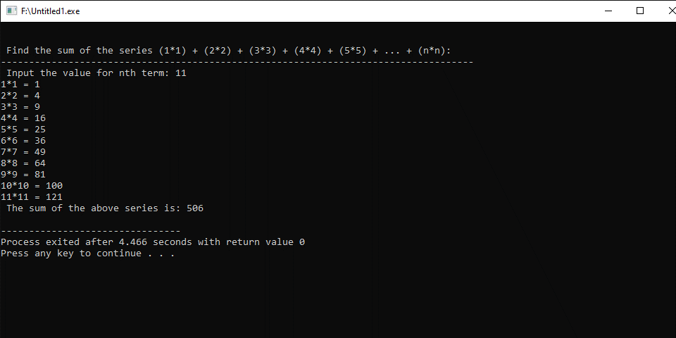
Write a program in C++ to calculate the series (1) + (1+2) + (1+2+3) + (1+2+3+4) + ... + (1+2+3+4+...+n).
#include <iostream>
using namespace std;

int main()
{
int i, j, n, sum = 0, tsum;
cout << "\n\n Find the sum of the series (1) + (1+2) + (1+2+3) + (1+2+3+4) + ... + (1+2+3+4+...+n):\n";
cout << "------------------------------------------------------------------------------------------\n";
cout << " Input the value for nth term: ";
cin >> n;
for (i = 1; i <= n; i++)
{
tsum = 0;
for (j = 1; j <= i; j++)
{
sum += j;
tsum += j;
cout << j;
if (j < i)
{
cout << "+";
}
}
cout << " = " << tsum << endl;
}
cout << " The sum of the above series is: " << sum << endl;
}
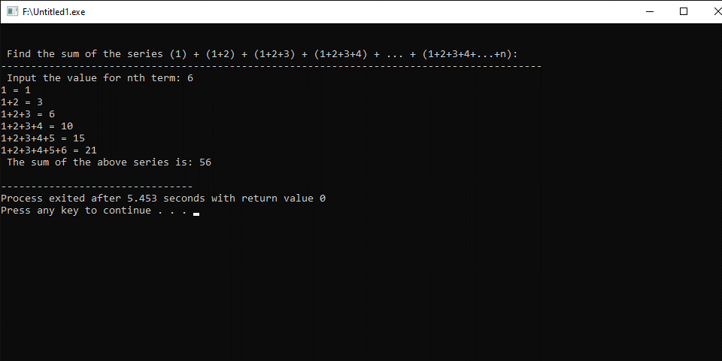

Write a program in C++ to list non-prime numbers from 1 to an upper bound.
#include <iostream>
#include <cmath>
using namespace std;

int main()
{
int ult;
cout << "\n\n List non-prime numbers from 1 to an upperbound:\n";
cout << "----------------------------------------------------\n";
cout << " Input the upperlimit: ";
cin >> ult;
cout << " The non-prime numbers are: " << endl;
for (int num = 2; num <= ult; ++num)
{
int mfactor = (int)sqrt(num);
for (int fact = 2; fact <= mfactor; ++fact)
{
if (num % fact == 0)
{
cout << num << " ";
break;
}
}
}
cout << endl;
return 0;
}
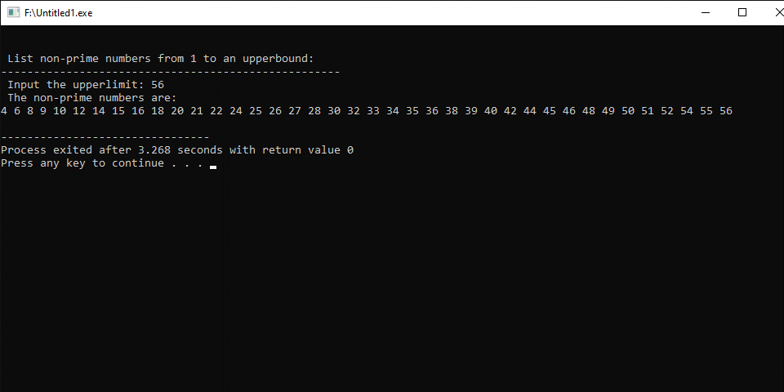

Write a program in C++ to print a square pattern with # character.
#include <iostream>
using namespace std;

main()
{
int size;
cout << "\n\n Print a pattern like square with # character:\n";
cout << "--------------------------------------------------\n";
cout << " Input the number of characters for a side: ";
cin >> size;
for (int row = 1; row <= size; ++row)
{
for (int col = 1; col <= size; ++col)
{
cout << "# ";
}
cout << endl;
}
}
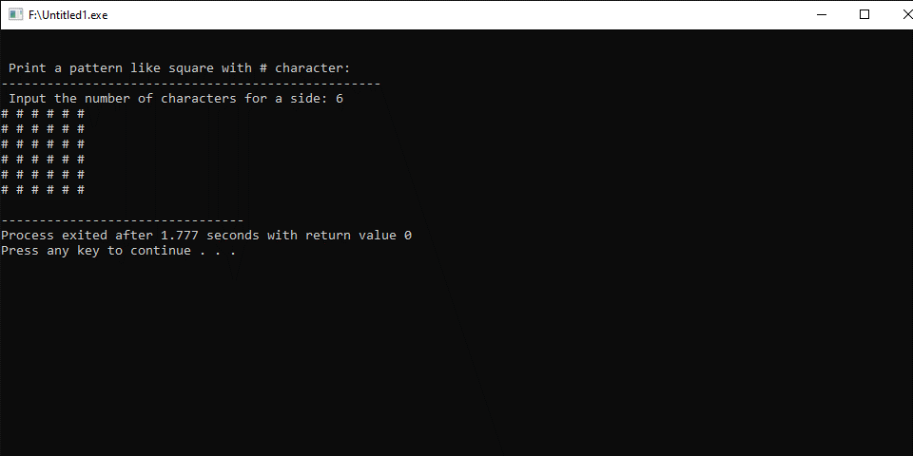

Program fundamental Lab report # 6

SUBMITTED BY:
ZULQARNAIN HASSAN

SUBMITTED TO:
SIR AAQIB ADEEL
Roll No : SP21379
Faculty: Engineering and computer science
Department: Software engineering
Section: BSSE-1-A-afternoon

- While loop
- Do-while loop
- Nested while loop

- While loop
The while loop loops through a block of code as long as a specified condition is trueDo not forget to increase the variable used in the condition, otherwise the loop will never end!

Syntax
while (condition)
{
// code block to be executed
}
- Do while loop:
The do/while loop is a variant of the while loop. This loop will execute the code block once, before checking if the condition is true, then it will repeat the loop as long as the condition is true.

Syntax
do
{
// code block to be executed
}
while (condition);
- Nested while loop:
If a while loop exists inside the body of another while loop, it's called a nested while loop.
Syntax
int i = 1;
while (i <= 5)
{
int j = 1;
while(j <=2)
{
// codes
++J;
} ..
++I;
}

Write C++ program to print alphabets from a to z:

#include <iostream>
using namespace std;

int main()
{
int character=0;
char ch='A';
do
{
character=int(ch);

cout<<ch<<" ";
character++;
ch=char(character);

}
while(ch<='Z');

}
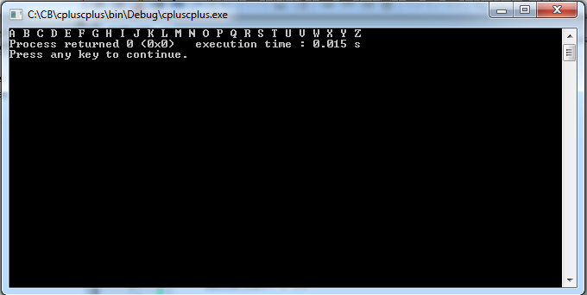

Write C++ program to print multiplication table of a given number

#include <iostream>
using namespace std;

int main()
{
int num=0, i=1;
cout<<"Enter number to print table: "<<endl;
cin>>num;
while(i<=10)
{
//Printing table of number entered by user
cout<<num<<" x "<<i << " = "<<num*i<<endl;
i++;
}
return 0;

}
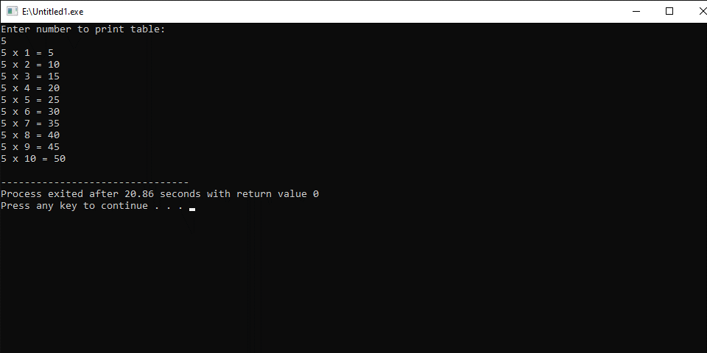

Write C++ program to print all natural numbers in reverse order
#include <iostream>
using namespace std;

int main()
{
int num=0, i;
cout<<"Enter any number: "<<endl;
cin>>num;
i=num;
while( i>=1)
{
cout<<i;
i--;
}
return 0;

}
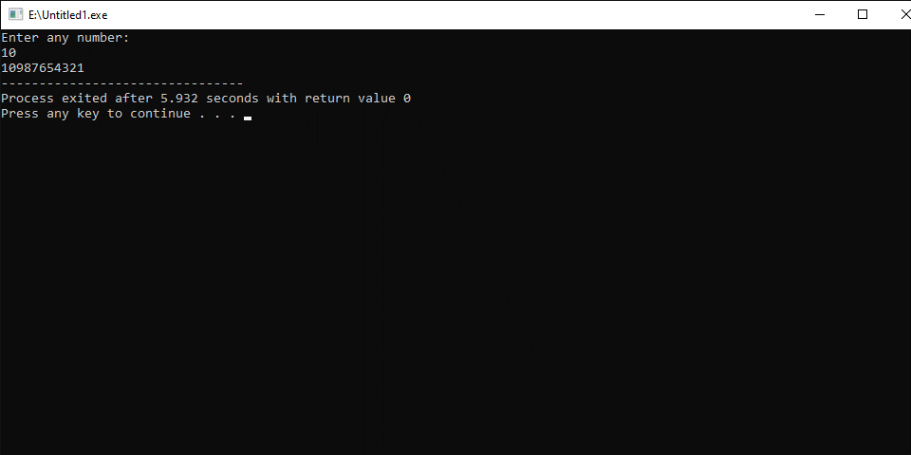

Write C++ program to print sum of digits enter by user
#include <iostream>
using namespace std;

int main()
{
int num, total;

cout<<"Enter any number: "<<endl;
cin>>num;
total = 0;
while( num > 0 )
{
total = total + (num%10);
num = num/10;
}

cout<<"Sum of digits: "<< total;
return 0;
}
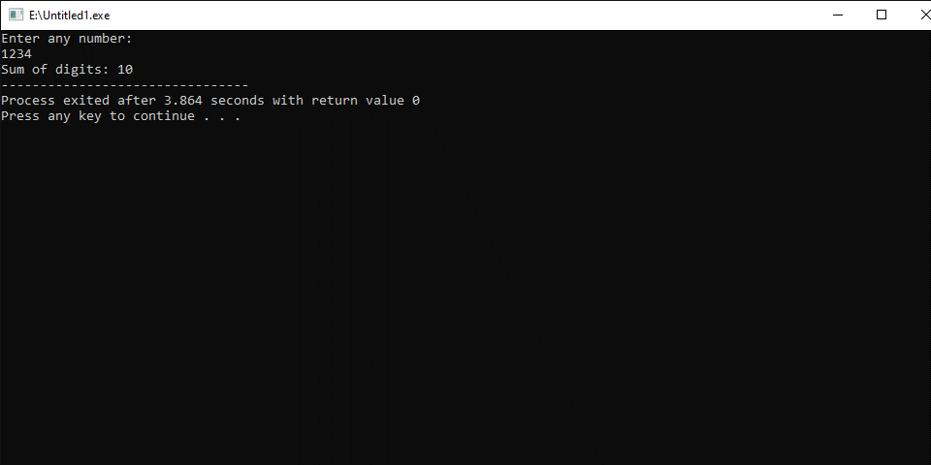

Write C++ program to reverse a number
#include <iostream>
#include <math.h>

using namespace std;

int main()
{
int num, rev = 0;
cout<<"Enter any number:";
cin>>num;
while (num > 0) {
rev = rev * 10;
rev = rev + num % 10;
num = num / 10;
}

cout<<"Reversed number is: "<<rev;

return 0;
}
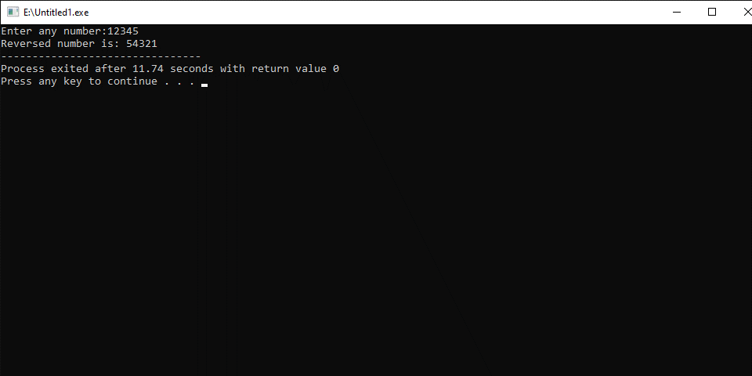

Write C++ program to check whether a number is Prime number or not using while loop
#include <iostream>
#include <math.h>

using namespace std;

int main()
{
int num, i, f;

//Reading a number from user
cout<<"Enter any number:";
cin>>num;

f = 0;
i = 2;
while(i <= num/2)
{
if(num%i == 0)
{
f=1;
break;
}
i++;
}
if(f == 0)

cout<<num<<" is a Prime Number"<<endl;
else

cout<<num<<" is Not a Prime Number"<<endl;

return 0;
}
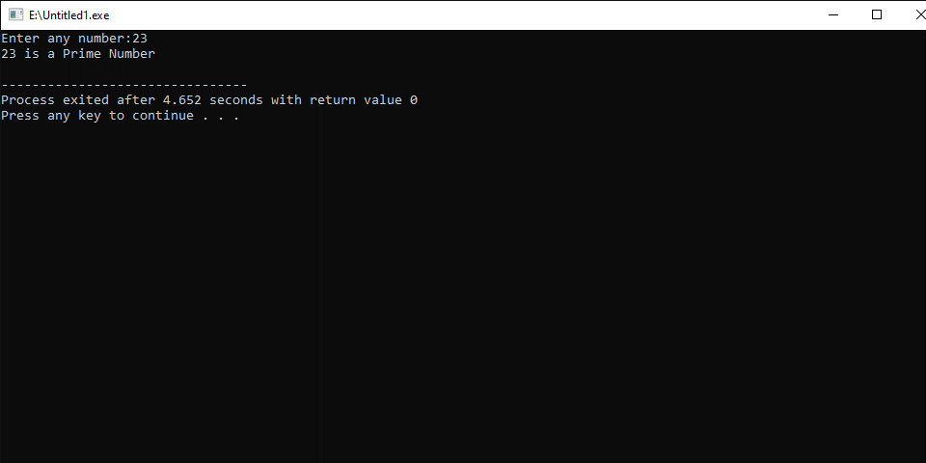

Write C++ program to print number in words

#include <iostream>

using namespace std;

int main()

{

int n, num = 0;

//Reading a number from user

cout<<"Enter any number to print in words: ";

cin>>n;

while(n != 0)

{

num = (num * 10) + (n % 10);

n /= 10;

}

//print corresponding digit in words till num becomes 0

while(num != 0)

{

switch(num % 10)

{

case 0: cout<<"zero ";

break;

case 1: cout<<"one ";

break;

case 2: cout<<"two ";

break;

case 3: cout<<"three ";

break;

case 4: cout<<"four ";

break;

case 5: cout<<"five ";

break;

case 6: cout<<"six ";

break;

case 7: cout<<"seven ";

break;

case 8: cout<<"eight ";

break;

case 9: cout<<"nine ";

break;

}

num = num / 10;

}

return 0;

}

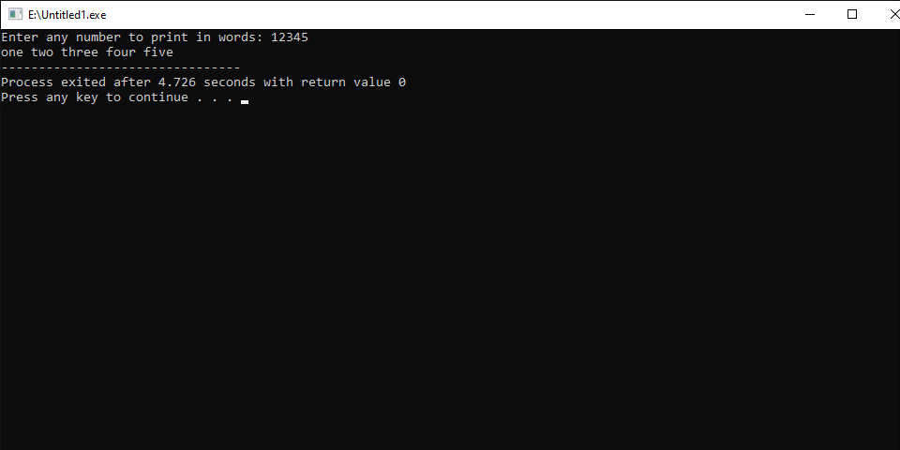

Write C++ program to find HCF of two numbers

#include <iostream>

using namespace std;

int main()

{

int i=1, num1, num2, min, HCF=1;

//Read two numbers from user

cout<<"Enter any two numbers:";

cin>>num1;

cin>>num2;

// Find min number between two numbers

min = (num1<num2) ? num1 : num2;

while( i<=min)

{

if(num1%i==0 && num2%i==0)

{

HCF = i;

}

i++;

}

cout<<"HCF of "<<num1<< " and "<< num2<< " is: " <<HCF;

return 0;

}
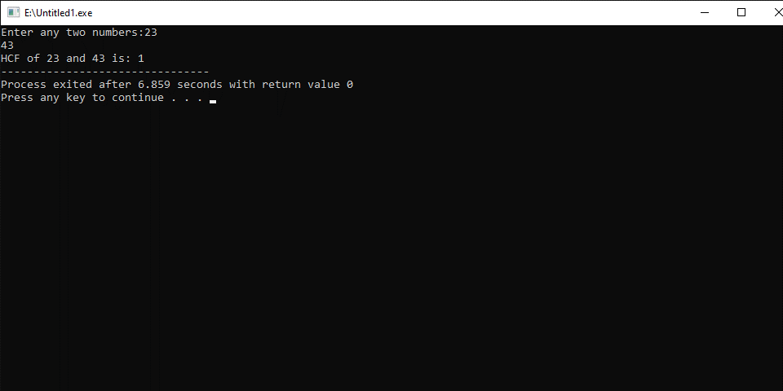

Write C++ program to find LCM of two numbers
#include <iostream>

using namespace std;

main()
{
int i=1, num1, num2, max, cm=1;
cout<<"Enter any two numbers:";
cin>>num1;
cin>>num2;

while(i<=num1*num2)
{
if(i%num1 == 0 && i%num2 == 0)
{
cm = i;
break;
}
i++;
}

cout<<"LCM of " << num1 << " and " <<num2<< " is "<< i;

}
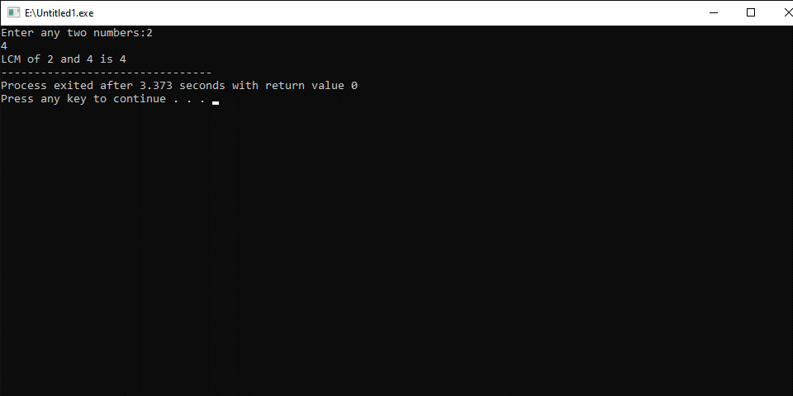

Program fundamental Lab report # 7

SUBMITTED BY:
ZULQARNAIN HASSAN

SUBMITTED TO:
SIR AAQIB ADEEL
Roll No : SP21379
Faculty: Engineering and computer science
Department: Software engineering
Section: BSSE-1-A-afternoon

Topics
- Array
- 2D array

- Array

Arrays are used to store multiple values in a single variable, instead of declaring separate variables for each value.
To declare an array, define the variable type, specify the name of the array followed by square brackets and specify the number of elements it should store:
Syntex:

string cars[n];

- 2D array
It consist of two dimension in the form of rows and coulomn.
To declare a multidimensional array, define the variable type, specify the name of the array followed by square brackets which specify how many elements the main array has, followed by another set of square brackets which indicates how many elements the sub-arrays have:

Syntex:

string letters[n][n];

Write C++ program to print all negative elements in an array
#include <iostream>
using namespace std;

int main()
{
int arr[50];
int i, num;
cout<<"Enter size of the array: ";
cin>>num;
cout<<"Enter elements in array: ";
for(i=0; i<num; i++)
{
cin>>arr[i];
}

cout<<"All negative elements in array are:";
for(i=0; i<num; i++)
{
if(arr[i] < 0)
{
cout<<arr[i];
}
}

return 0;
}
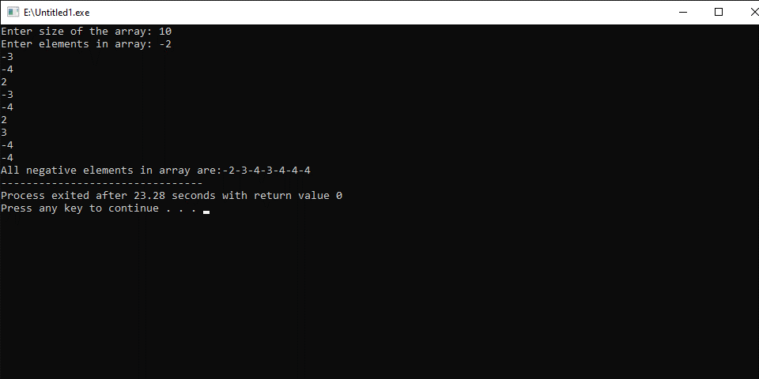

Write C++ program to count total number of negative elements in array
#include <iostream>
using namespace std;

int main()
{
int arr[100];
int i, num, count=0;
cout<<"Enter size of the array : ";
cin>>num;

cout<<"Enter elements in array : ";
for(i=0; i<num; i++)
{
cin>>arr[i];
}
for(i=0; i<num; i++)
{
if(arr[i]<0)
{
count++;
}
}
cout<<"Total number of negative elements: "<<count;

return 0;
}


Write C++ program to read and print elements of array

#include <iostream>

using namespace std;

int main()

{

int arr[50];

int i, num;

cout<<"Enter size of array: ";

cin>>num;

cout<<"Enter "<<num<< " elements in the array :";

for(i=0; i<num; i++)

{

cin>>arr[i];

}

cout<<"\nElements in array are: ";

for(i=0; i<num; i++)

{

cout<<arr[i]<<"\t";

}

return 0;

}
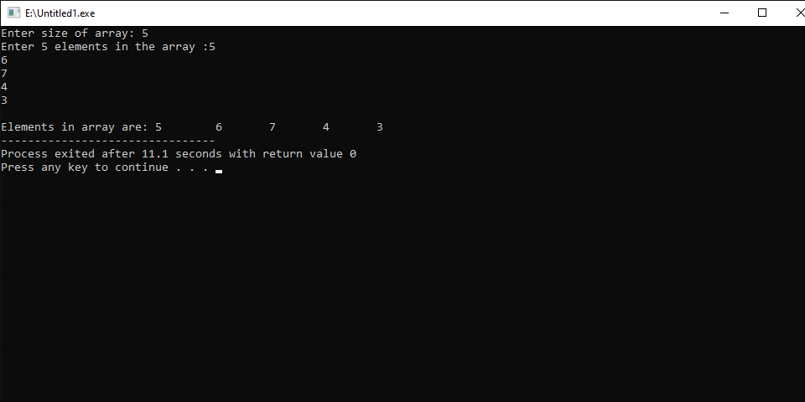

Write C++ program to find sum of all elements of an array
#include <iostream>

using namespace std;
main()
{
int arr[100];
int i, num, sum=0;

cout<<"Enter size of the array: ";
cin>>num;
cout<<"Enter "<<num<< "elements in the array: "<<endl;

for(i=0; i<num; i++)
{
cin>>arr[i];
}

for(i=0; i<num; i++)
{
sum = sum + arr[i];
}
cout<<"Sum of all elements of array: "<< sum;

}
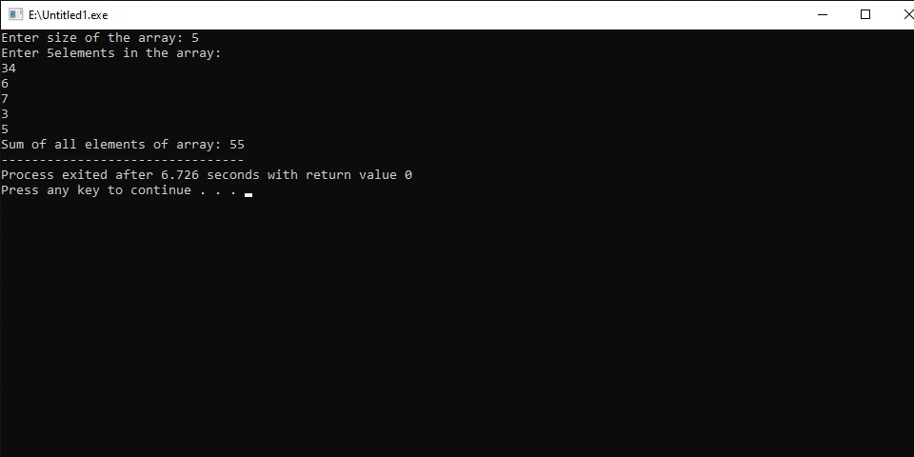

Write C++ program to count even and odd elements in an array

#include <iostream>

using namespace std;

int main()

{

int arr[100];

int i, num, evennum, oddnum;

cout<<"Enter size of the array: ";

cin>>num;

cout<<"Enter "<<num<<" elements in array: ";

for(i=0; i<num; i++)

{

cin>>arr[i];

}

evennum = 0;

oddnum = 0;

for(i=0; i<num; i++)

{

if(arr[i]%2 == 0)

{

evennum++;

}

else

{

oddnum++;

}

}

cout<<"Total even numbers: "<<evennum<<endl;

cout<<"Total odd numbers: "<<oddnum<<endl;

return 0;

}
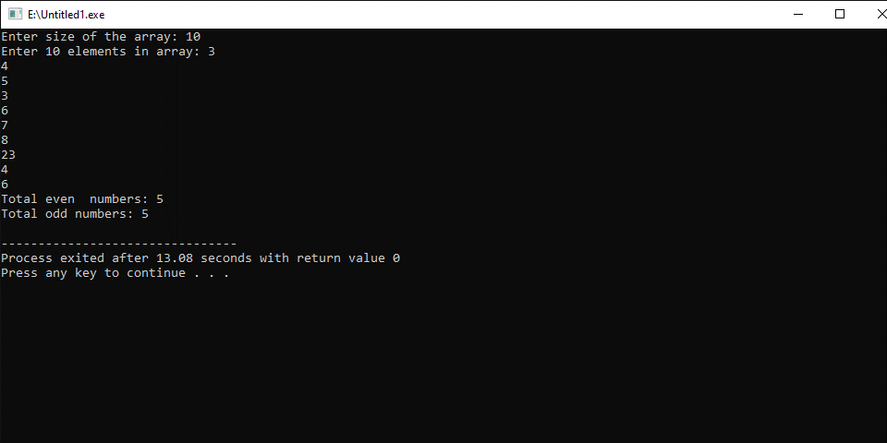

Write C++ program to find maximum and minimum element in array
#include <iostream>

using namespace std;

int main()
{

int arr[100];
int i, max, min, size;

cout<<"Enter size of the array: ";
cin>>size;
cout<<"Enter elements in the array: ";
for(i=0; i<size; i++)
{
cin>>arr[i];
}

max = arr[0];
min = arr[0];

for(i=1; i<size; i++)
{

if(arr[i]>max)
{
max = arr[i];
}

if(arr[i]<min)
{
min = arr[i];
}
}

cout<<"Maximum element is: "<<max<<endl;
cout<<"Minimum element is: "<<min<<endl;
return 0;
}
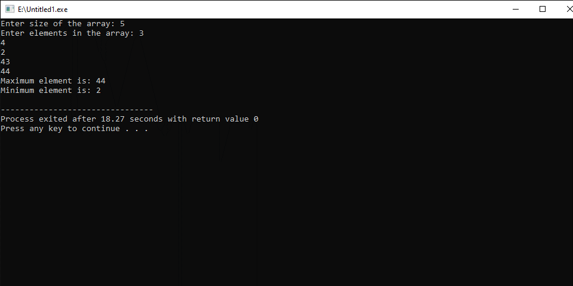

Write C++ program to print all unique element in an array
#include <iostream>
using namespace std;

main()
{
int arr[100], size, isUnique;
int i, j, k;
cout<<"Enter size of array: ";
cin>>size;

cout<<"Enter elements in array: ";
for(i=0; i<size; i++)
{
cin>>arr[i];
}
for(i=0; i<size; i++)
{
isUnique = 1;

for(j=i+1; j<size; j++)
{

if(arr[i]==arr[j])
{
for(k=j; k<size-1; k++)
{
arr[k] = arr[k+1];
}

size--;
j--;
isUnique = 0;
}
}
if(isUnique != 1)
{
for(j=i; j<size-1; j++)
{
arr[j] = arr[j+1];
}

size--;
i--;
}
}

cout<<"All unique elements in the array are: ";
for(i=0; i<size; i++)
{
cout<<arr[i]<<"\t";
}

}
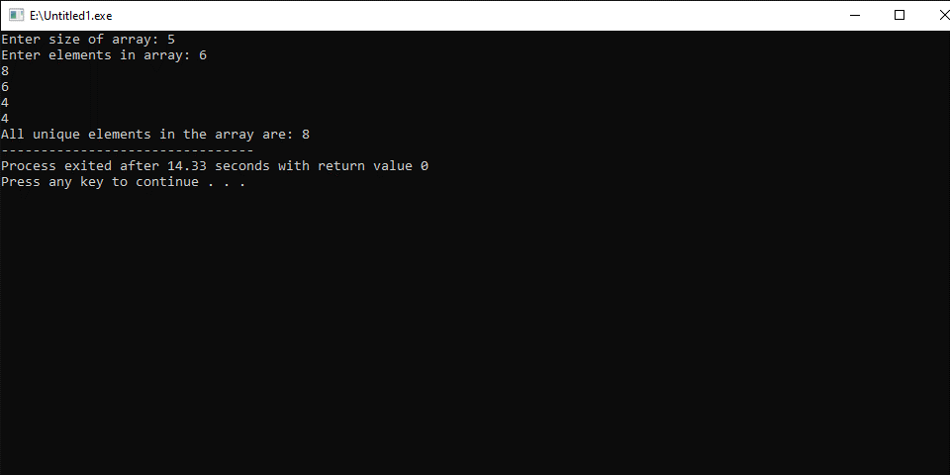

Write C++ program to copy all elements of one array to another
#include <iostream>
using namespace std;

int main()
{
int first[50], second[50];
int i, num;
cout<<"Enter the size of the array : ";
cin>>num;
cout<<"Enter elements of first array : ";
for(i=0; i<num; i++)
{
cin>>first[i];
}
for(i=0; i<num; i++)
{
second[i] = first[i];
}
cout<<"Elements of first array are:"<<endl;
for(i=0; i<num; i++)
{
cout<<first[i]<<"\t";
}
cout<<"\nElements of second array are: \n ";
for(i=0; i<num; i++)
{
cout<<second[i]<<"\t";
}

return 0;
}
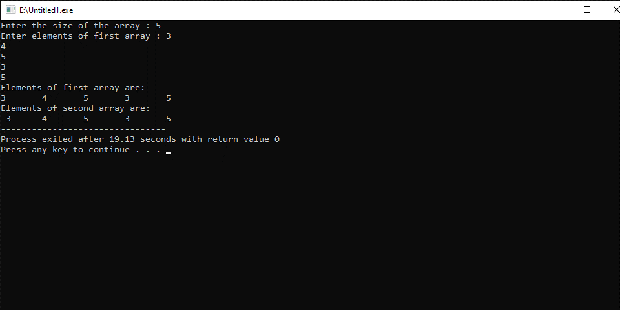

Write C++ program to count total duplicate elements in an array
#include <iostream>
using namespace std;

int main()
{
int arr[100];
int i, j, n, count = 0;
cout<<"Enter size of the array : ";
cin>>n;
cout<<"Enter elements in array : ";
for(i=0; i<n; i++)
{
cin>>arr[i];
}
for(i=0; i<n; i++)
{
for(j=i+1; j<n; j++)
{

if(arr[i] == arr[j])
{
count++;
break;
}
}
}
cout<<"\nTotal number of duplicate elements found in array: "<<count;

return 0;
}
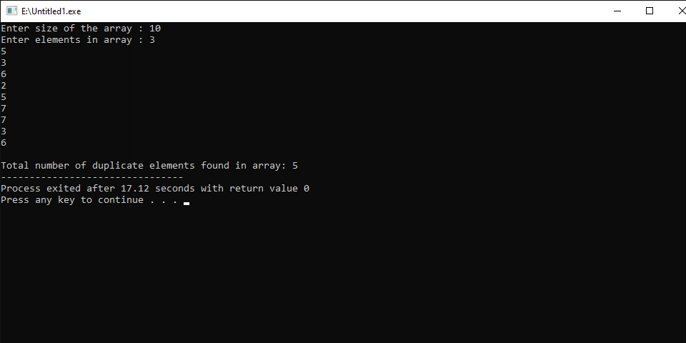

Write C++ program to count number of each element in an array
#include <iostream>
using namespace std;

main()
{
int arr[100], frequency[100];
int i, j, count, num;
cout<<"Enter size of array: ";
cin>>num;
cout<<"Enter elements in array: ";
for(i=0; i<num; i++)
{
cin>>arr[i];
frequency[i] = -1;
}

for(i=0; i<num; i++)
{
count = 1;
for(j=i+1; j<num; j++)
{
if(arr[i]==arr[j])
{
count++;

frequency[j] = 0;
}
}
if(frequency[i] != 0)
{
frequency[i] = count;
}
}
cout<<"\nFrequency of all elements of array : \n";
for(i=0; i<num; i++)
{
if(frequency[i] != 0)
{
cout<<arr[i]<<" occurs "<<frequency[i]<<" times\n";
}
}

}
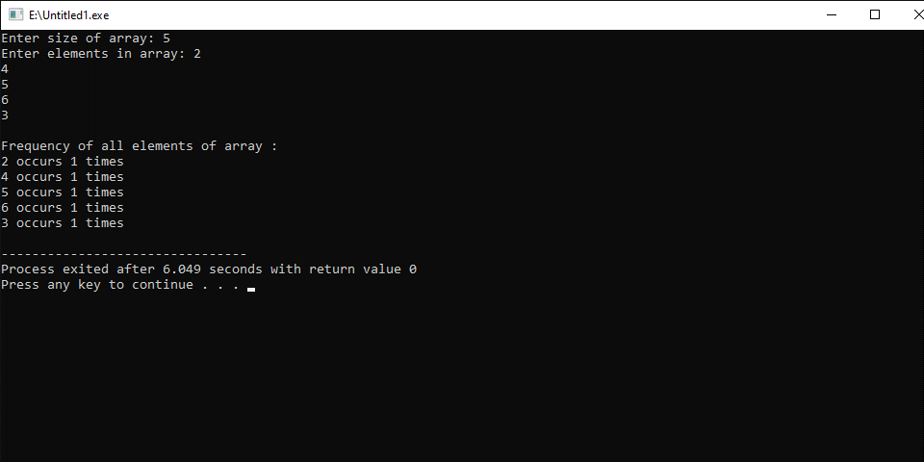

Program fundamental Lab report # 8

SUBMITTED BY:
ZULQARNAIN HASSAN

SUBMITTED TO:
SIR AAQIB ADEEL
Roll No : SP21379
Faculty: Engineering and computer science
Department: Software engineering
Section: BSSE-1-A-afternoon

Topics
- Function
A function is a block of code which only runs when it is called.You can pass data, known as parameters, into a function.
Functions are used to perform certain actions, and they are important for reusing code: Define the code once, and use it many times.
C++ provides some pre-defined functions, such as main(), which is used to execute code. But you can also create your own functions to perform certain actions.

Parameters and Arguments
Information can be passed to functions as a parameter. Parameters act as variables inside the function.
Parameters are specified after the function name, inside the parentheses. You can add as many parameters as you want, just separate them with a comma:

Return Values
If you want the function to return a value, you can use a data type (such as int, string, etc.) instead of void, and use the return keyword inside the function:

Write C++ program to check even or odd using functions
#include <iostream>
using namespace std;

int isEven(int num)
{
return !(num & 1);
}

int main(){

int num;
cout<<"Enter any number: ";
cin>>num;
if(isEven(num))
{
cout<<"The entered number is even.";
}
else
{
cout<<"The entered number is odd.";
}

return 0;

}
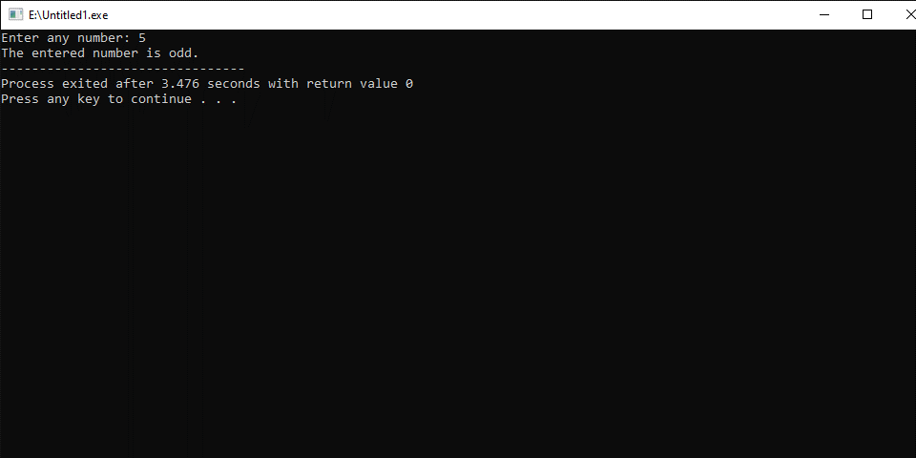

Write C++ program to check prime and armstrong numbers using function
#include <iostream>
#include <math.h>
using namespace std;

int checkPrimeNumber(int n);
int checkArmstrongNumber(int n);

int main(){

int num, flag;

cout<<"Enter a positive integer: ";
cin>>num;
flag = checkPrimeNumber(num);
if (flag == 1)
cout<<num<<" is a prime number"<<endl;
else
cout<<num<<" is not a prime number"<<endl;
flag = checkArmstrongNumber(num);
if (flag == 1)
cout<<num<<" is a Armstrong number"<<endl;
else
cout<<num<<" is a not an Armstrong number"<<endl;
return 0;
}
int checkPrimeNumber(int num)
{
int i, flag = 1;

for(i=2; i<=num/2; ++i)
{
if(num%i == 0)
{
flag = 0;
break;
}
}
return flag;
}
int checkArmstrongNumber(int number)
{
int originalNumber, remainder, result = 0, num = 0, flag;

originalNumber = number;

while (originalNumber != 0)
{
originalNumber /= 10;
++num;
}

originalNumber = number;

while (originalNumber != 0)
{
remainder = originalNumber%10;
result += pow(remainder, num);
originalNumber /= 10;
}

if(result == number)
flag = 1;
else
flag = 0;

return flag;
}
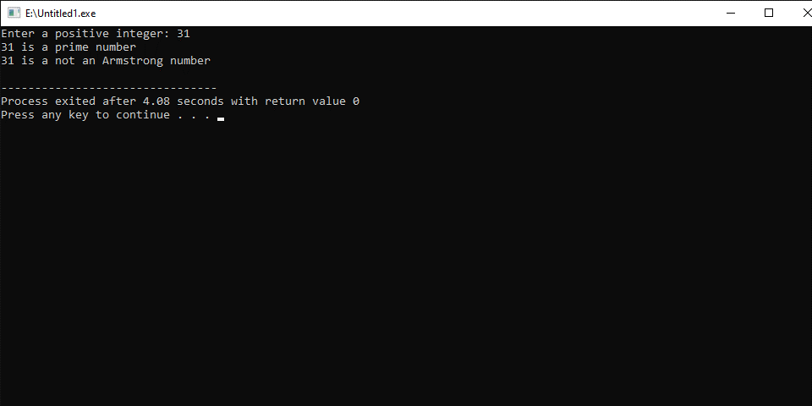

Write C++ program to find cube of a number using function
#include <iostream>
using namespace std;
double cube(double num);

int main()
{
int num;
double c;
cout<<"Enter any number: "<<endl;
cin>>num;

c = cube(num);

cout<<"Cube of " <<num << " is "<<c;

return 0;
}
double cube(double num)
{
return (num * num * num);
}
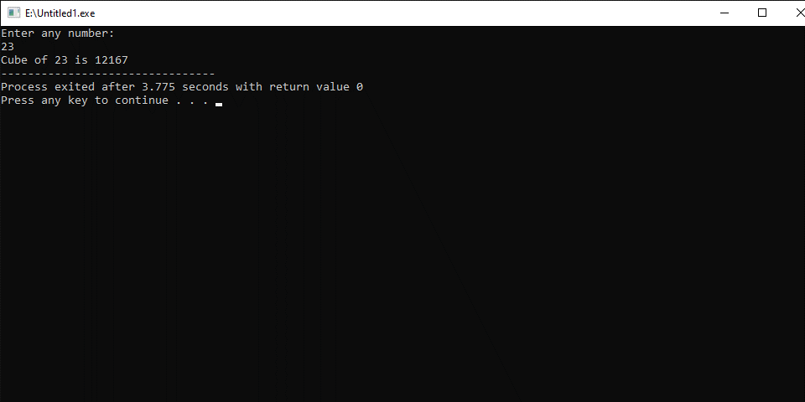

Write C++ program to convert binary number to decimal
#include <iostream>
#include <math.h>
using namespace std;
int convertBinaryToDecimal(long long n);

int main()
{
long long n;
cout<<"Enter a binary number: ";
cin>>n;
cout<<n<<" in binary = "<<convertBinaryToDecimal(n)<<" in decimal";
return 0;
}
int convertBinaryToDecimal(long long n)
{
int decimalNumber = 0, i = 0, remainder;
while (n!=0)
{
remainder = n%10;
n /= 10;
decimalNumber += remainder*pow(2,i);
++i;
}
return decimalNumber;
}
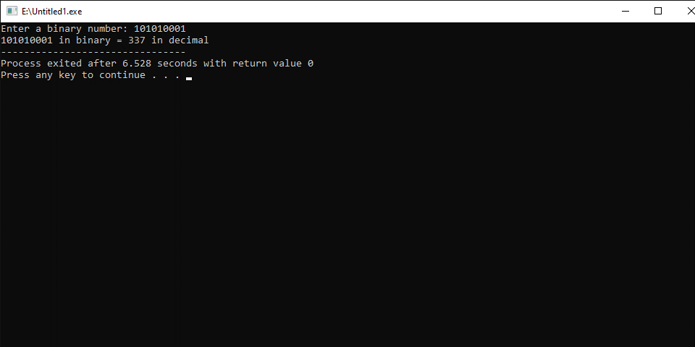

Write C++ program to find Length of the String by passing String/Character

#include <iostream>
#include <math.h>
using namespace std;
int stringLength(char *);

int main()
{
char text[100];
int length;

cout<<"Enter text (max- 100 characters): ";
cin>>text;

length = stringLength(text);

cout<<"Input text is: "<<text<<endl;
cout<<"Length is: "<<length<<endl;

return 0;
}

int stringLength(char *str)
{
int len=0;
for(len=0; str[len]!='\0'; len++);
return len;
}
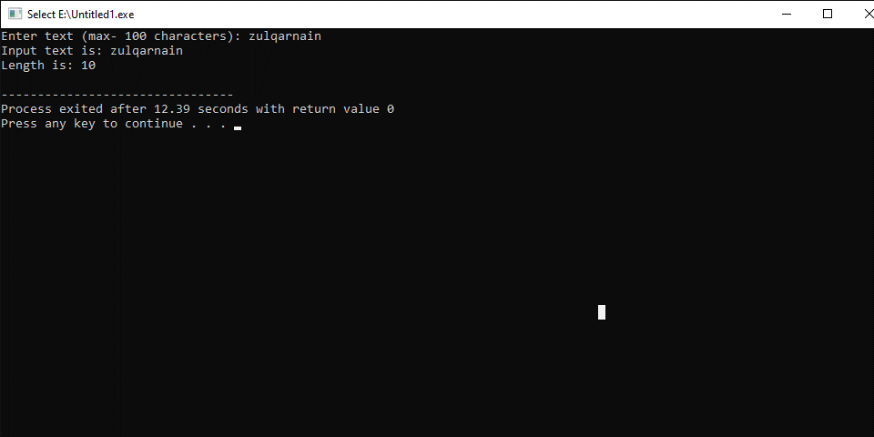

Write C++ program to find prime numbers in given range using functions
#include <iostream>
using namespace std;
int isPrime(int num);
void printPrimes(int lower, int upper);

int main()
{
int lower, upper;

cout<<"Enter the lower and upper limit to list primes: ";
cin>>lower;
cin>>upper;
printPrimes(lower, upper);
return 0;
}
void printPrimes(int lower, int upper)
{
cout<<"List of prime numbers between "<<lower <<" and "<<upper <<" are: "<<endl;

while(lower <= upper)
{
if(isPrime(lower))
{
cout<<lower<<endl;
}

lower++;
}
}
int isPrime(int num)
{
int i;

for(i=2; i<=num/2; i++)
{
if(num % i == 0)
{
return 0;
}
}

return 1;
}
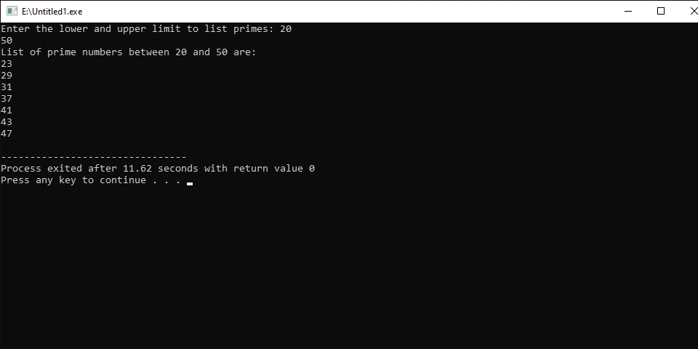

Write C++ program to find diameter, circumference and area of circle using function
#include <iostream>
#include <math.h>
using namespace std;
double getDiameter(double radius);
double getCircumference(double radius);
double getArea(double radius);

int main()
{
float radius, diameter, circle, area;
cout<<"Enter radius of circle: ";
cin>>radius;

diameter = getDiameter(radius);
circle = getCircumference(radius);
area = getArea(radius);

cout<<"Diameter of the circle: "<<diameter <<" units"<<endl;
cout<<"Circumference of the circle: "<< circle<<" units"<<endl;
cout<<"Area of the circle:"<< area<<" sq. units"<<endl;

return 0;
}
double getDiameter(double radius)
{
return (2 * radius);
}
double getCircumference(double radius)
{
return (2 * 3.14 * radius);
}
double getArea(double radius)
{
return (3.14 * radius * radius);
}
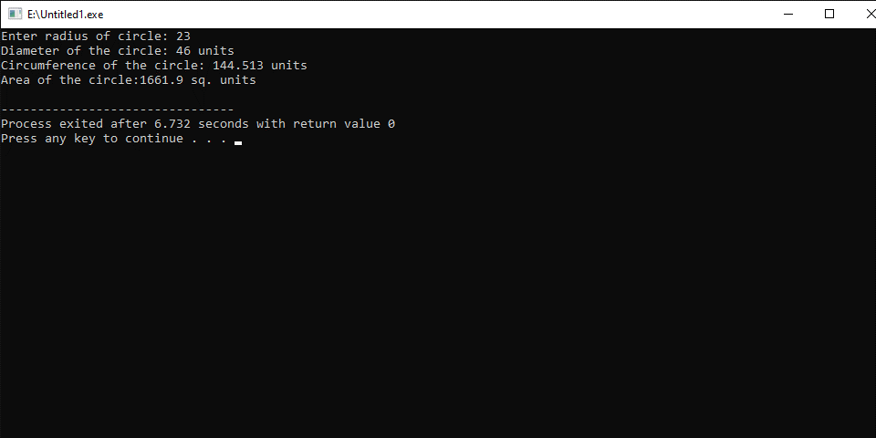

Program fundamental Lab report # 9

SUBMITTED BY:
ZULQARNAIN HASSAN

SUBMITTED TO:
SIR AAQIB ADEEL
Roll No : SP21379
Faculty: Engineering and computer science
Department: Software engineering
Section: BSSE-1-A-afternoon

Pointer
A pointer is a variable that stores the memory address of an object. Pointers are used extensively in both C and C++ for three main purposes: to allocate new objects on the heap, to pass functions to other functions.
Not only can a pointer store the address of a single variable, it can also store the address of cells of an array.

Programs
Write a program that print the address of a variable.
#include <iostream>
using namespace std;

main()
{
int b=10;
int *a;
a=&b;
cout<<a;
cout<<endl;
cout<<&b;
cout<<endl;
cout<<b;
}
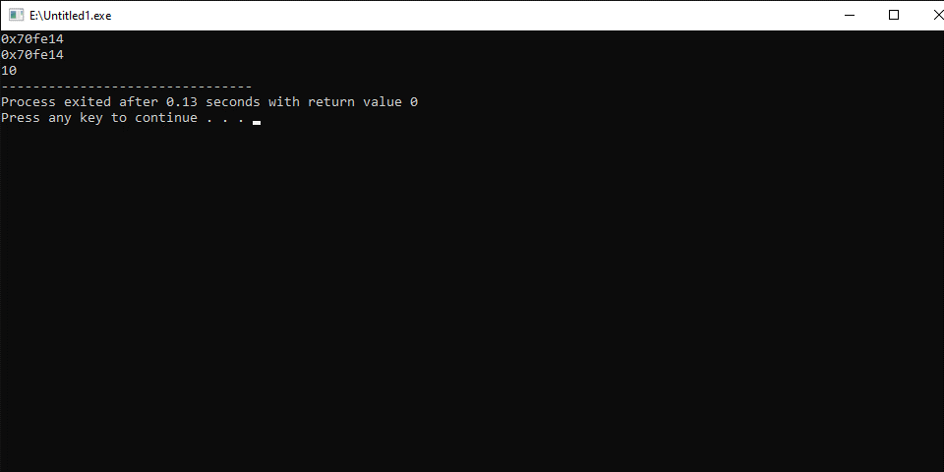
Write a program that stores an integer in a variable and also prints it using a pointer.
#include <iostream>
using namespace std;

main()
{
int b;
int *a;
a=&b;
cin>>*a;
cout<<a;
cout<<endl;
cout<<&b;
cout<<endl;
cout<<b;
}
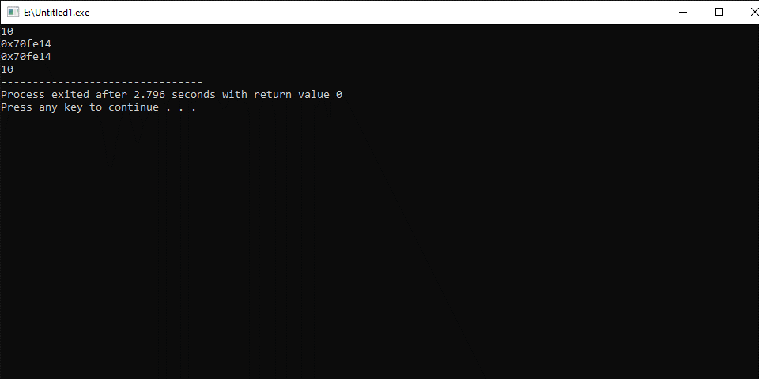
Write C++ program to swap two numbers using pointers.
#include <iostream>
using namespace std;
void swap(int *num1, int *num2) {
int temp;
temp = *num1;
*num1 = *num2;
*num2 = temp;
}

main() {
int num1, num2;
cout<<"\nEnter the first number : ";
cin>>num1;
cout<<"\nEnter the Second number : ";
cin>>num2;
swap(&num1, &num2);
cout<<"\nFirst number : "<< num1;
cout<<"\nSecond number: "<<num2;
}
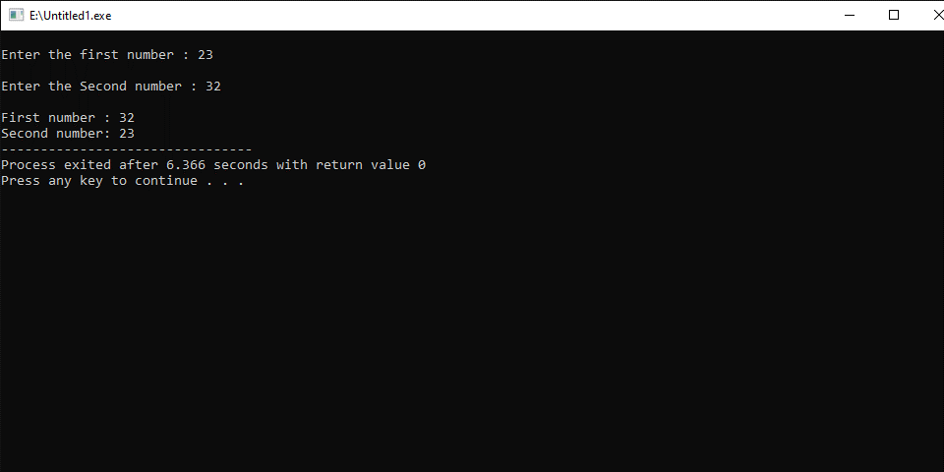
Write C++ program to add two numbers using pointers
#include <iostream>
using namespace std;

int main() {

int num1, num2, *ptr1, *ptr2, sum=0;
cout<<"Enter the two number :";
cin>>num1>>num2;
ptr1 = &num1;
ptr2 = &num2;
sum = *ptr1 + *ptr2;
cout<<"Sum of the two number is "<<sum;

return 0;

}
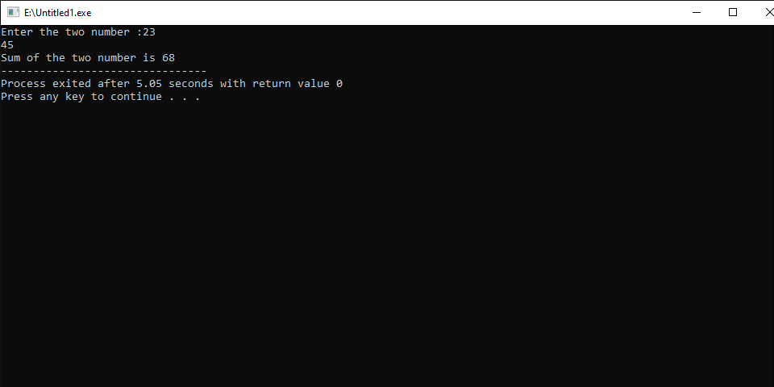
Write C++ program to Sum of Array Elements using Pointers
#include <iostream>
using namespace std;

main() {

int arr[5], i, sum = 0;
int *ptr;

cout << "Enter any 5 numbers :";
for (i = 0; i < 5; i++) {
cin >> arr[i];
}

ptr = arr;
for (i = 0; i < 5; i++) {
sum = sum + *(ptr + i);
}

cout << "\nSum of array elements :" << sum;

}
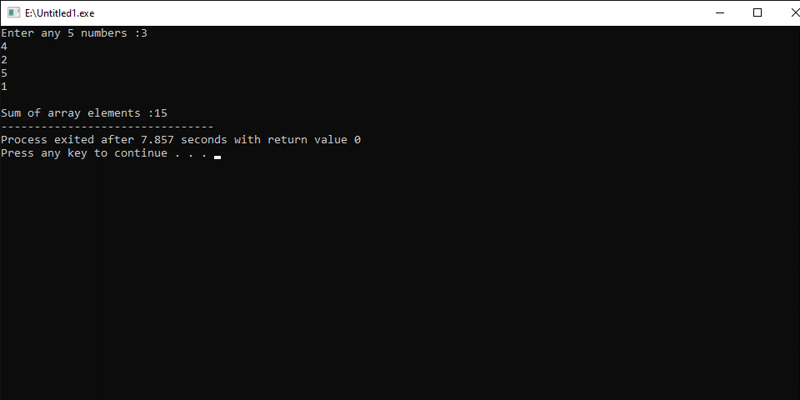
Write C++ program to find length of string using pointer
#include <iostream>
using namespace std;

int main() {

char text[100];
char * str = text;
int count = 0;
cout<<"Enter any string: ";
cin>>text;
while(*(str++) != '\0') count++;

cout<<"Length of "<<text<<" is "<<count;

return 0;
}
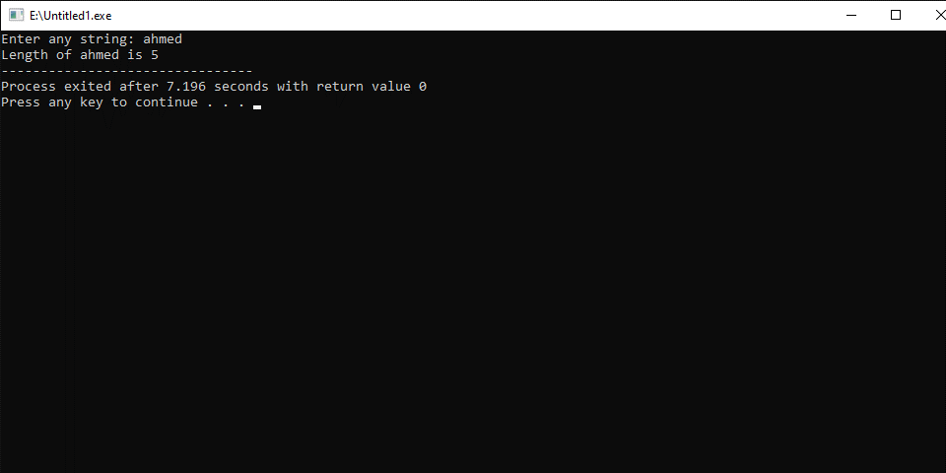
Write C++ program to copy one string to another string using pointer
#include <iostream>
using namespace std;

main() {

char text1[100], text2[100];
char * str1 = text1;
char * str2 = text2;
cout<<"Enter any string: "<<endl;
cin>>text1;
while(*(str2++) = *(str1++));

cout<<"First string: "<<text1<<endl;;
cout<<"Second string: "<<text2<<endl;

}
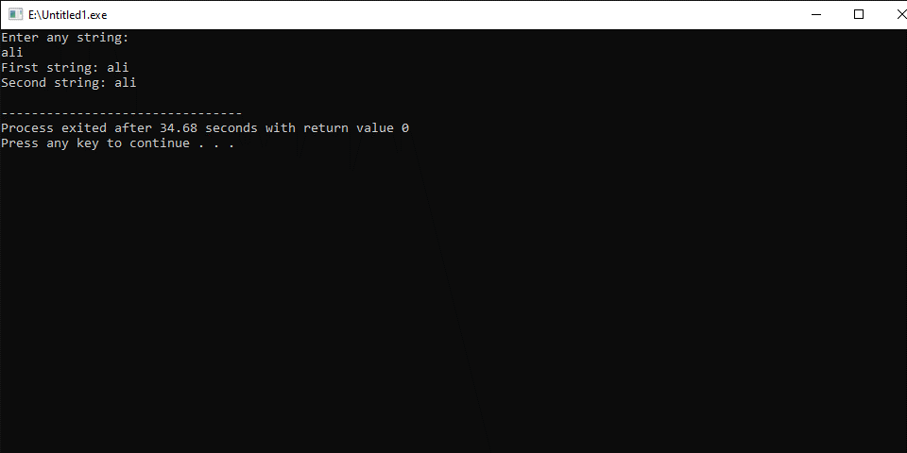
Write C++ program to concatenate two strings using pointer
#include <iostream>
#define MAX_SIZE 100 // Maximum size of the string
using namespace std;

int main() {

char str1[MAX_SIZE], str2[MAX_SIZE];
char * s1 = str1;
char * s2 = str2;
cout<<"Enter 1st string: ";
cin>>str1;
cout<<"Enter 2nd string: ";
cin>>str2;
while(*(++s1));
while(*(s1++) = *(s2++));

cout<<"Concatenated string:"<<str1;

return 0;

}
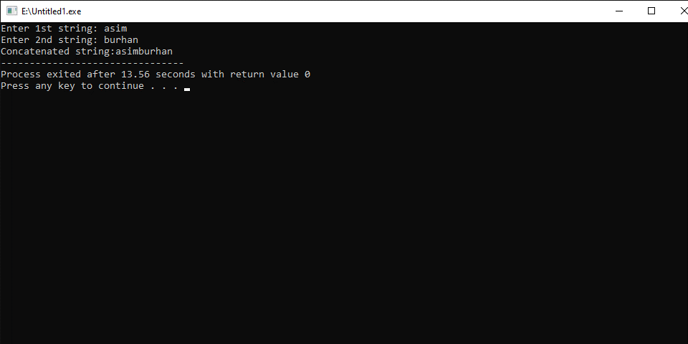
Write C++ program to print the elements of the array in reverse order using a pointer.
#include <iostream>
using namespace std;

int main() {

int arr[5],i;
int *p=arr;
cout<<"Enter five numbers separated by space:";
cin>>*p>>*(p+1)>>*(p+2)>>*(p+3)>>*(p+4);
cout<<"Your entered numbers in reverse order are:\n";
for(i=4;i>=0;i--)
cout<<*(p+i)<<endl;

return 0;

}
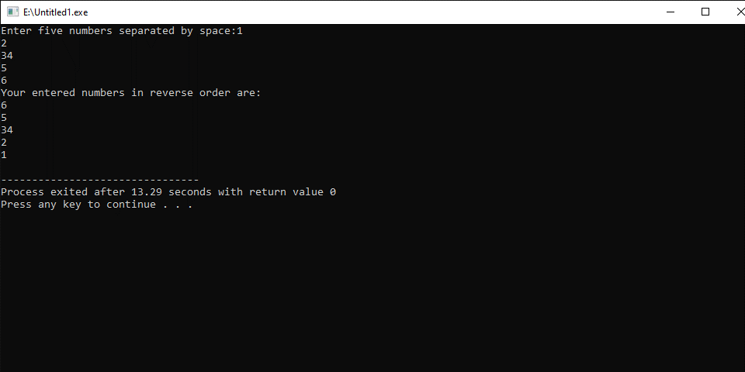

Program fundamental Lab report # 10

SUBMITTED BY:
ZULQARNAIN HASSAN

SUBMITTED TO:
SIR AAQIB ADEEL
Roll No : SP21379
Faculty: Engineering and computer science
Department: Software engineering
Section: BSSE-1-A-afternoon

Structure
A structure can be defined as a single entity holding variables of different data types that are logically related to each other. All the data members inside a structure are accessible to the functions defined outside the structure.

Write a program that using structure that print the properties of book.
#include<iostream>
using namespace std;
struct book
{
string title;
int page;
float price;

};

main()
{
book a;
a.page=3333;
a.price=400.55;
a.title="ali_baba";
cout<<a.page<<" "<<a.price<<" "<<a.title<<" ";
}
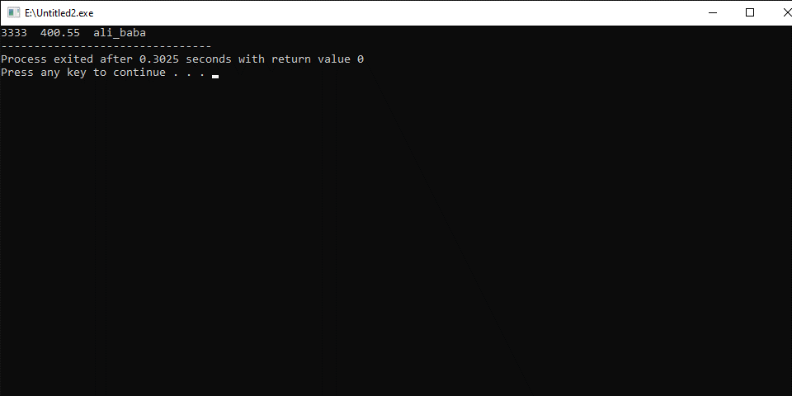
Write a program using structure inside another structure.
#include <iostream>
using namespace std;
struct address
{
string city_name;
int postel_code;

};
struct employee
{
string name;
int age;
float hight;
struct address b;
};
main()
{
employee a;

cin>>a.age>>a.hight>>a.name;
cin>>a.b.city_name>>a.b.postel_code;

cout<<a.age<<a.hight<<a.name;
cout<<a.b.city_name<<a.b.postel_code;

}
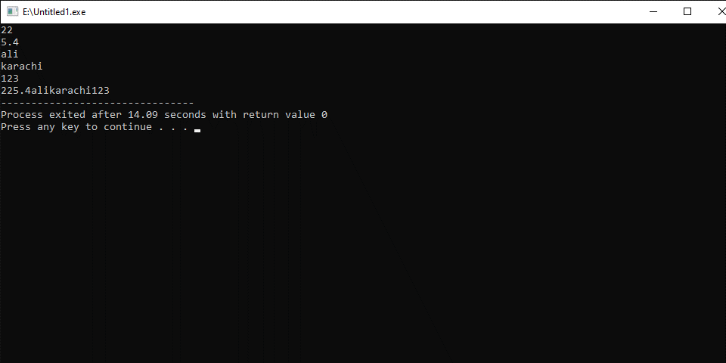
Write a program to store and print the roll no., name , age and marks of a student using structures.
#include<iostream>
using namespace std;
struct student
{
int roll_no;
string name;
int age;
int marks;
};
int main()
{

struct student p1;
p1.roll_no=1;
p1.name="Ahmed";
p1.age=19;
p1.marks=899;
cout << p1.roll_no << " " << p1.name << " " << p1.age << " " << p1.marks << "\n";
return 0;
}
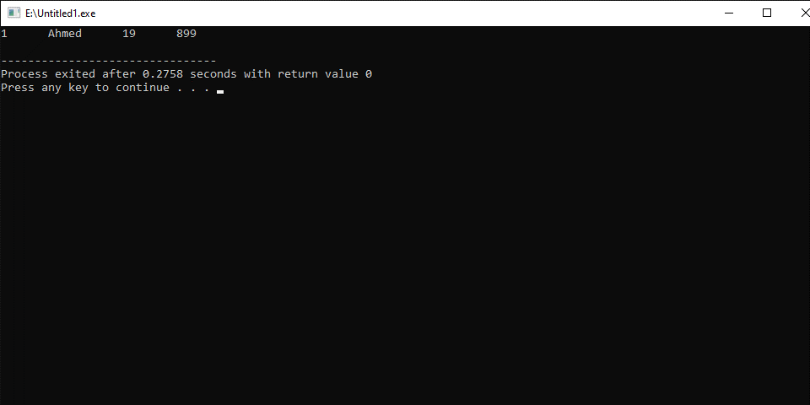

Write a program to store the roll no. (starting from 1), name and age of 5 students and then print the details of the student with roll no. 2.
#include<iostream>
using namespace std;
int main()
{
struct student
{
int roll_no;
string name;
int age;
};

struct student stud[5];

for(int i=0; i<=4; i++)
{
cout << "Student " << i+1 << endl;
stud[i].roll_no = i+1;
cout << "Enter name :\n";
cin >> stud[i].name;
cout << "Enter age :\n";
cin >> stud[i].age;
}

for(int i=0; i<=4; i++)
{
if(stud[i].roll_no == 2)
{
cout << "Student " << i+1 << endl;
cout << "Roll no. : " << stud[i].roll_no << endl;
cout << "Name : " << stud[i].name << endl;
cout << "Age : " << stud[i].age << endl;
}
}

return 0;
}
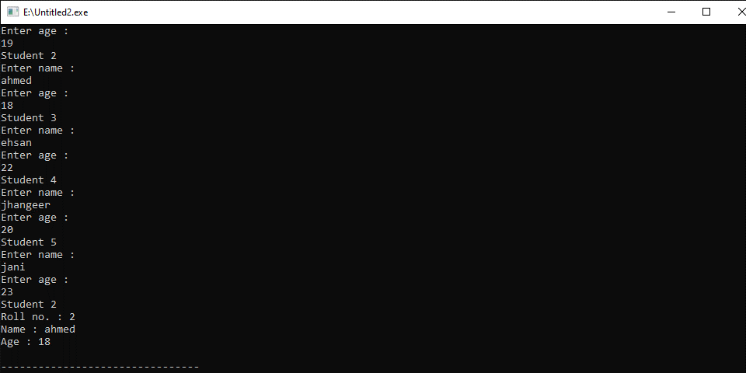
Write a program to add two distances in inch-feet using structure. The values of the distances is to be taken from the user.
#include<iostream>
using namespace std;
struct dist
{
int feet;
int inch;
};

struct dist add(struct dist a, struct dist b)
{
struct dist d;
d.feet = a.feet+b.feet;
if(a.inch+b.inch >= 12)
{
d.feet = d.feet+((a.inch+b.inch)/12);
d.inch = (a.inch+b.inch)-(((a.inch+b.inch)/12)*12);
}
else
{
d.inch = a.inch+b.inch;
}
return d;
}

int main()
{
struct dist d1 = {12,2};
struct dist d2 = {14,11};

struct dist d = add(d1,d2);

cout << d.feet << " feet and " << d.inch << " inch" << endl;
return 0;
}
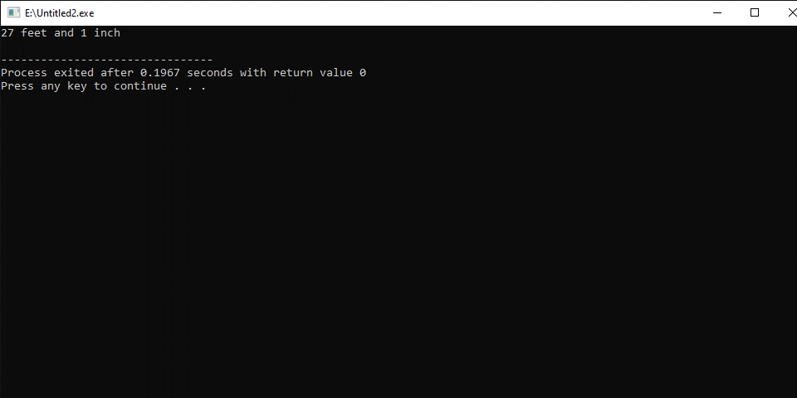

Write a program to add, subtract and multiply two complex numbers using structures to function.
#include<iostream>
using namespace std;
struct complex
{

int real;
int imag;
};

struct complex add(struct complex a, struct complex b)
{
struct complex d;
d.real = a.real+b.real;
d.imag = a.imag+b.imag;
return d;
}

struct complex sub(struct complex a, struct complex b)
{
struct complex d;
d.real = a.real-b.real;
d.imag = a.imag-b.imag;
return d;
}

struct complex multiply(struct complex a, struct complex b)
{
struct complex d;
d.real = (a.real*b.real)-(a.imag*b.imag);
d.imag = (a.real*b.imag)+(a.imag*b.real);
return d;
}

int main()
{
struct complex d1 = {12,2};
struct complex d2 = {14,11};

struct complex d = add(d1,d2);
struct complex e = sub(d1,d2);
struct complex f = multiply(d1,d2);

cout << "ADD - " << d.real << "+" << d.imag << "i\n";
cout << "SUB - " << e.real << "+" << e.imag << "i\n";
cout << "MUL - " << f.real << "+" << f.imag << "i\n";

return 0;
}
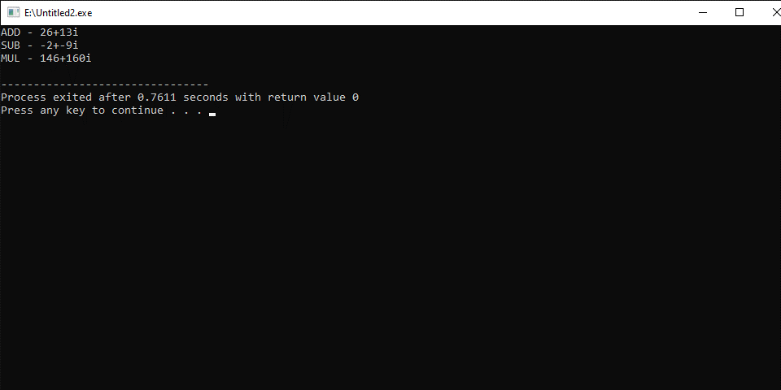

Write a program that read sides and print name of triangle if it is isosceles and find third angle using structure.
#include<iostream>
using namespace std;
struct triangle
{

int side1;
int side2;
int side3;
float angle1;
float angle2;
float angle3;
};

main()
{
struct triangle a;
a.angle1=60.45;
a.angle2=90.999;
cin>>a.side1;
cin>>a.side2;
cin>>a.side3;
if(a.side1==a.side2||a.side3==a.side2||a.side3==a.side1)
{
cout<<"triangle is Isoseles";
}
cout <<"\nangle3 is = "<<180-a.angle1-a.angle2;
}
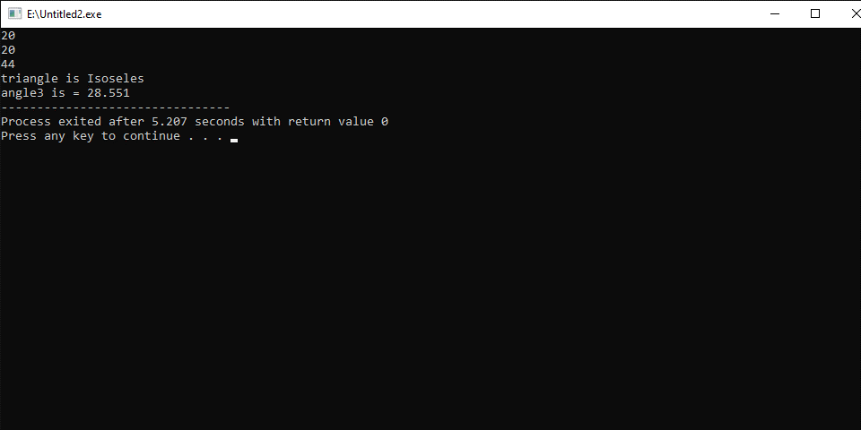

Write a program using structure inside another structure.
#include <iostream>
using namespace std;
struct address
{
string city_name;
int postel_code;

};
struct employee
{
string name;
int age;
float hight;
struct address b;
}
main()
{
employee a;

cin>>a.age>>a.hight>>a.name;
cin>>a.b.city_name>>a.b.postel_code;

cout<<a.age<<a.hight<<a.name;
cout<<a.b.city_name<<a.b.postel_code;

}
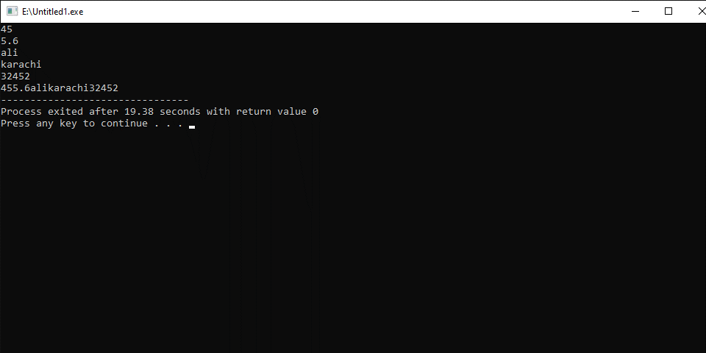

THE
END

